PISHPEK
No information has been found for this period yet
42.87882, 74.55696

Фотография пока не добавлена
ENGLISH
No information has been found for this period yet.

FRUNZE
Brotherly cemetery
42.87882, 74.55696
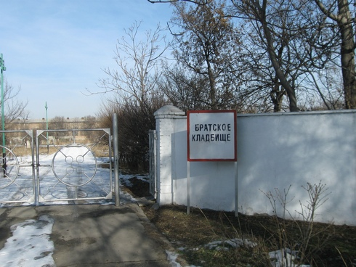
Братское кладбище
ENGLISH Brotherly cemetery
﻿ Brotherly cemetery In 1935-56 it was the Kyzylasker city cemetery. Here is a mass grave of soldiers who died of wounds during the Great Patriotic War in hospitals in the city of Frunze.
Source: https://bimap.su/description/frunze/10_Bratskoe_kladbiche.txt · BIMAP
Фотографии и материалы принадлежат их авторам; лицензия не указана

BISHKEK
No information has been found for this period yet
42.87882, 74.55696

Фотография пока не добавлена
ENGLISH
No information has been found for this period yet.

