PISHPEK
No information has been found for this period yet
42.87092, 74.60263

Фотография пока не добавлена
ENGLISH
No information has been found for this period yet.

FRUNZE
House on Kirgizskaya
42.87092, 74.60263
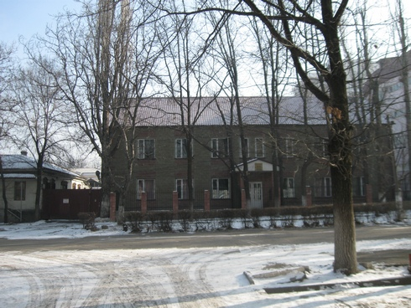
Дом на Киргизской · Владимира Петрова
ENGLISH House on Kirgizskaya
﻿ House on Kirgizskaya. Photo by Petrov One of the first 2-story houses, built in 1940 as the building of the “Sports Committee”.
Source: https://bimap.su/description/frunze/6_Dom_na_Kirgizskoy.txt · BIMAP
Фотографии и материалы принадлежат их авторам; лицензия не указана

BISHKEK
No information has been found for this period yet
42.87092, 74.60263

Фотография пока не добавлена
ENGLISH
No information has been found for this period yet.

