PISHPEK
House under a reed roof
42.87445, 74.60467
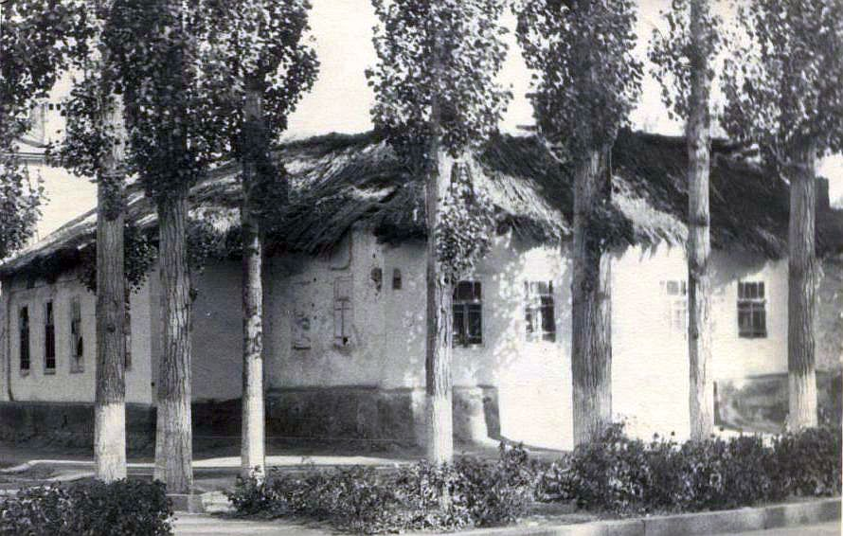
Дом под камышевой крышей
ENGLISH House under a reed roof
﻿ House under a reed roof on the south-eastern corner of Vasilievskaya-Dunganskaya streets The construction of residential buildings in the city of Pishpek was carried out strictly according to plan. Rectilinear streets formed squares or rectangles of blocks and in one block there were four to six plots, each with an area of ​​0.1 hectares. Houses on courtyard estates were placed on the corner or in the center of the site, with the main facades f
Source: https://bimap.su/description/pishpek/21_Dom_pod_kamyshom.txt · BIMAP
Фотографии и материалы принадлежат их авторам; лицензия не указана

FRUNZE
No information has been found for this period yet
42.87445, 74.60467

Фотография пока не добавлена
ENGLISH
No information has been found for this period yet.

BISHKEK
No information has been found for this period yet
42.87445, 74.60467

Фотография пока не добавлена
ENGLISH
No information has been found for this period yet.

