PISHPEK
No information has been found for this period yet
42.88375, 74.61379

Фотография пока не добавлена
ENGLISH
No information has been found for this period yet.

FRUNZE
House on Baetov Street
42.88375, 74.61379
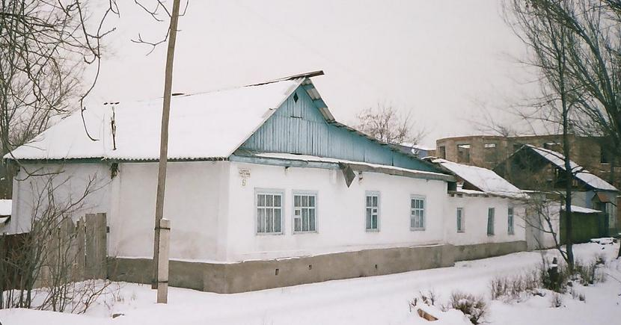
Дом на улице Баетова
ENGLISH House on Baetov Street
﻿ Northern side of Baetov Street corner of Almaatinskaya In the central part of the city, many houses of the old Pishpek have been preserved, largely rebuilt and equipped with modern amenities.
Source: https://bimap.su/description/frunze/3a_Dom_na_Baetova.txt · BIMAP
Фотографии и материалы принадлежат их авторам; лицензия не указана

BISHKEK
No information has been found for this period yet
42.88375, 74.61379

Фотография пока не добавлена
ENGLISH
No information has been found for this period yet.

