PISHPEK
No information has been found for this period yet
42.87088, 74.60919

Фотография пока не добавлена
ENGLISH
No information has been found for this period yet.

FRUNZE
House on Krasnooktyabrskaya
42.87088, 74.60919
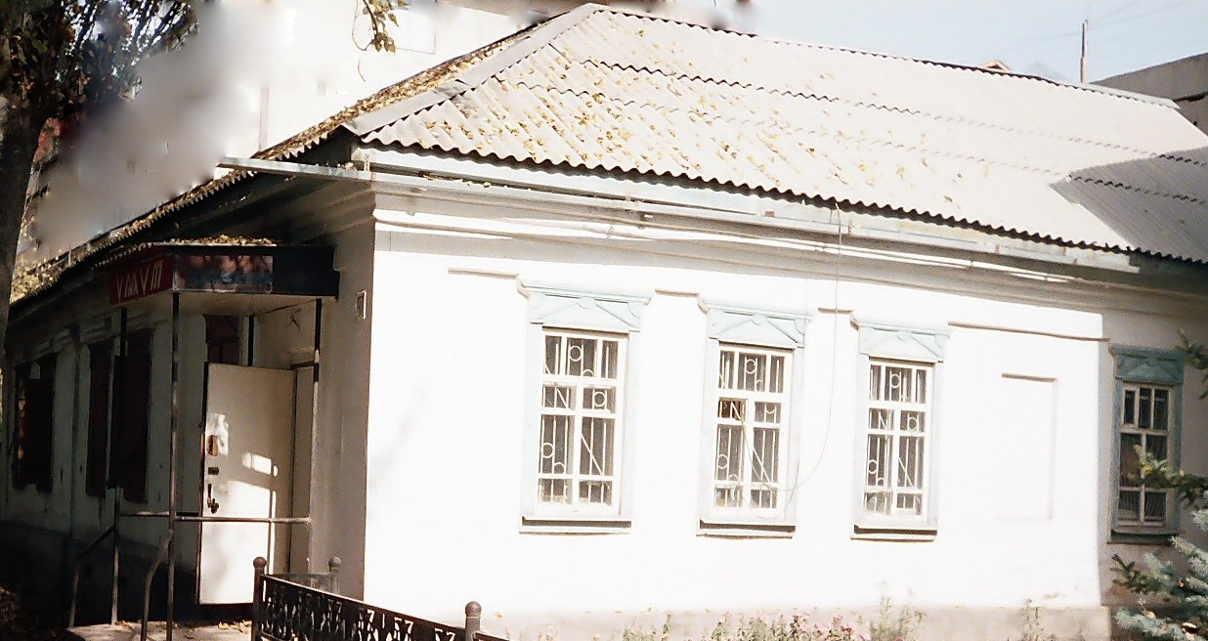
Дом на Краснооктябрьской · Никиты Часова
ENGLISH House on Krasnooktyabrskaya
﻿ House at the intersection of Krasnooktyabrskaya and Kalinin. Photo by Chasov. In the central part of the city, many houses of old Pishpek have been preserved, largely rebuilt and equipped with modern amenities.
Source: https://bimap.su/description/frunze/3_Dom_na_Krasnooktiabrskoy.txt · BIMAP
Фотографии и материалы принадлежат их авторам; лицензия не указана

BISHKEK
No information has been found for this period yet
42.87088, 74.60919

Фотография пока не добавлена
ENGLISH
No information has been found for this period yet.

