PISHPEK
No information has been found for this period yet
42.88987, 74.61131

Фотография пока не добавлена
ENGLISH
No information has been found for this period yet.

FRUNZE
House on the corner of Sovetskaya and Kurenkeeva streets
42.88987, 74.61131
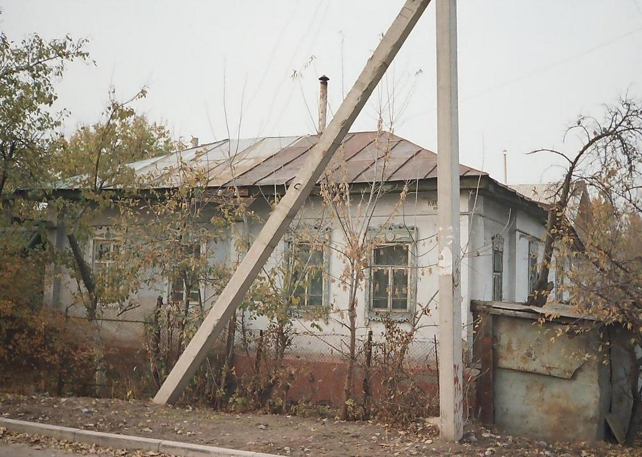
Дом на углу улиц Советской и Куренкеева
ENGLISH House on the corner of Sovetskaya and Kurenkeeva streets
﻿ House on the corner of Sovetskaya and Kurenkeeva streets Private sector houses occupied a significant place in the total area of ​​urban development. These are small one-story houses, built of mud or baked bricks with 3-4 rooms, with a veranda, summer kitchen and other courtyard buildings with small gardens and front gardens. Entire areas of the city below the streets of 50let Kirghiz SSR (Zhibek Zholu) and above the railway, as well as the Wor
Source: https://bimap.su/description/frunze/2_Dom_na_Sovetskoy.txt · BIMAP
Фотографии и материалы принадлежат их авторам; лицензия не указана

BISHKEK
No information has been found for this period yet
42.88987, 74.61131

Фотография пока не добавлена
ENGLISH
No information has been found for this period yet.

