PISHPEK
No information has been found for this period yet
42.86932, 74.60557

Фотография пока не добавлена
ENGLISH
No information has been found for this period yet.

FRUNZE
Dzerzhinsky Boulevard
42.86932, 74.60557
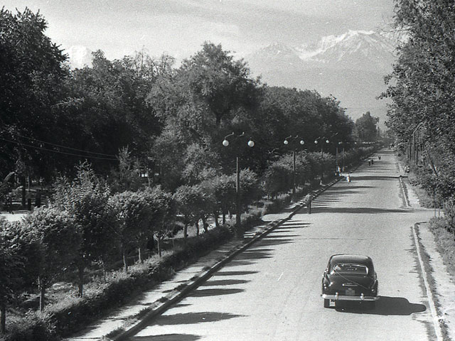
Бульвар Дзержинского · 60-х годов
ENGLISH Dzerzhinsky Boulevard
﻿ Dzerzhinsky Boulevard. Photo of the 60s Dzerzhinsky Avenue boulevard type. It stretches from south to north from the station to the Avenue named after the 50th anniversary of the Kyrgyz SSR, the length is 2.2 km. Until 1924 - st. Boulevard, then st. Komsomolskaya, since 1933 - st. Dzerzhinsky, since 1960 - a boulevard under the same name, since 1979 - an avenue. Laid down in 1883 by A.M. Fetisov, like an alley of 2 rows of silver poplar from th
Source: https://bimap.su/description/frunze/1c_Bulvar_Dzerzhinskogo.txt · BIMAP
Фотографии и материалы принадлежат их авторам; лицензия не указана

BISHKEK
No information has been found for this period yet
42.86932, 74.60557

Фотография пока не добавлена
ENGLISH
No information has been found for this period yet.

