PISHPEK
No information has been found for this period yet
42.85627, 74.60541

Фотография пока не добавлена
ENGLISH
No information has been found for this period yet.

FRUNZE
Alley to the Agricultural Institute
42.85627, 74.60541
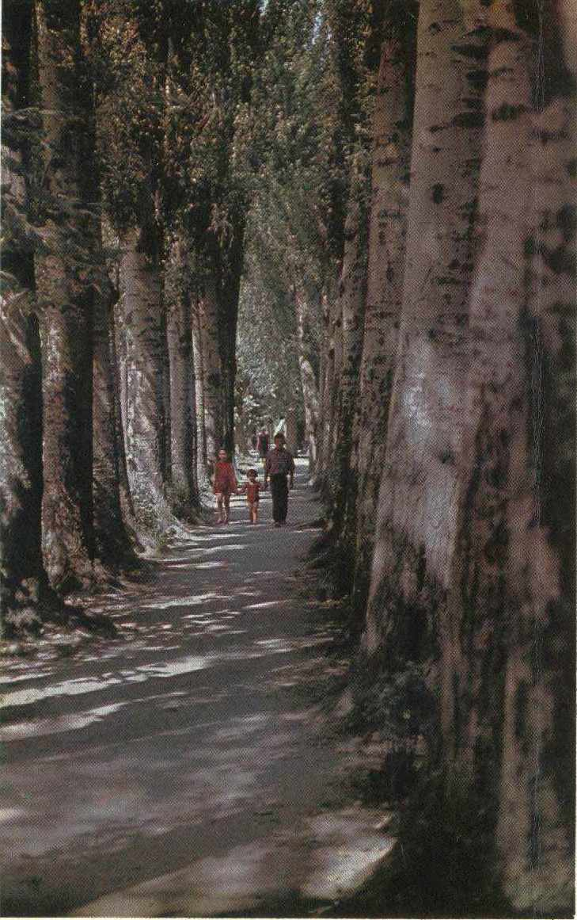
Аллея к сельхозинституту
ENGLISH Alley to the Agricultural Institute
﻿ Alley to the Agricultural Institute, st. Fatyanova, above Gorky The beginning of urban landscaping was made when drawing up a plan for the county town at the end of the 19th century. Irrigation canals (aryks) were built in the city, rows of trees were planted along the sidewalks, and the first boulevards, Oak Park, State Garden and Karagachevaya Grove were laid out. In Soviet times, the Botanical Garden, the Frunzensky Green Farm and the State
Source: https://bimap.su/description/frunze/1b_Alleia_k_selxozinstitutu.txt · BIMAP
Фотографии и материалы принадлежат их авторам; лицензия не указана

BISHKEK
No information has been found for this period yet
42.85627, 74.60541

Фотография пока не добавлена
ENGLISH
No information has been found for this period yet.

