PISHPEK
Old City Cemetery
42.88412, 74.62026
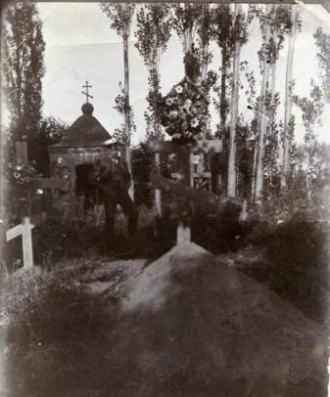
Старое городское кладбище
ENGLISH Old City Cemetery
﻿ Old City Cemetery An entire generation of pioneers of the city of Pishpek are buried in the unmarked graves of the old city cemetery. The destruction of the cemetery began in 1918, when cast iron cannons cast in St. Petersburg were stolen from the grave of the city elder Ilya Terentyev and installed in Oak Park on the mass grave of the Red Guards. In the 60s of the twentieth century, the Issyk-Kul cinema was built at the cemetery and a park was
Source: https://bimap.su/description/pishpek/200_Old_town_cemetry.txt · BIMAP
Фотографии и материалы принадлежат их авторам; лицензия не указана

FRUNZE
No information has been found for this period yet
42.88412, 74.62026

Фотография пока не добавлена
ENGLISH
No information has been found for this period yet.

BISHKEK
No information has been found for this period yet
42.88412, 74.62026

Фотография пока не добавлена
ENGLISH
No information has been found for this period yet.

