PISHPEK
Uyezdnaya Street
42.87944, 74.60731
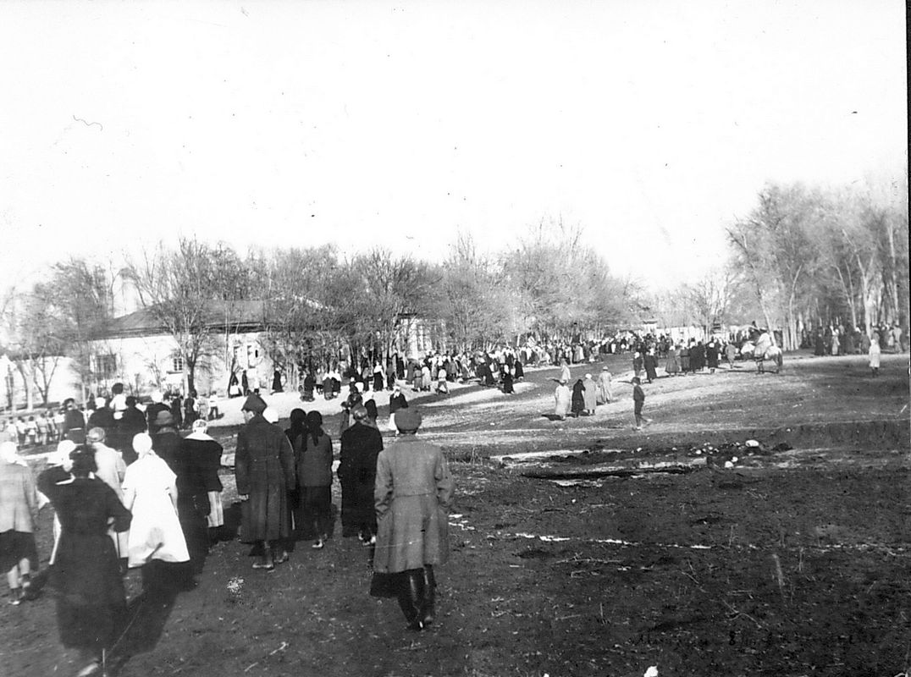
Улица Уездная
ENGLISH Uyezdnaya Street
﻿ Uyezdnaya Street The streets of the city of Pishpek, built up mainly with rural-type houses, almost untouched by landscaping, without any covering, buried in dust in the summer, were covered with mud during periods of rain. The city was decorated with green spaces that created life-giving shade, and full-flowing ditches with murmuring water and fresh winds brought coolness from the mountains. By 1913, the city already had 40 streets, the area o
Source: https://bimap.su/description/pishpek/195_Uezdnaia.txt · BIMAP
Фотографии и материалы принадлежат их авторам; лицензия не указана

FRUNZE
No information has been found for this period yet
42.87944, 74.60731

Фотография пока не добавлена
ENGLISH
No information has been found for this period yet.

BISHKEK
No information has been found for this period yet
42.87944, 74.60731

Фотография пока не добавлена
ENGLISH
No information has been found for this period yet.

