PISHPEK
Pishpek Resettlement Hospital
42.86711, 74.59692
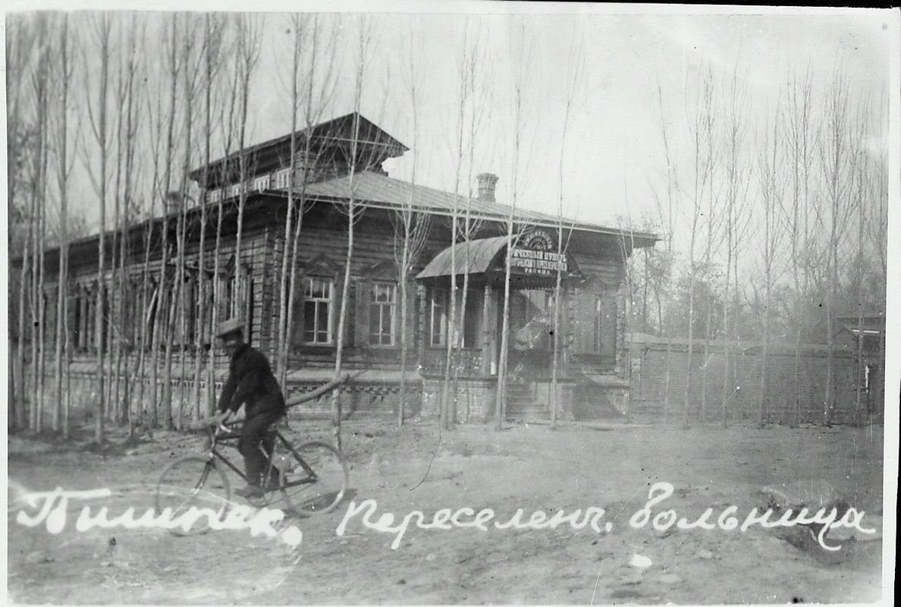
Переселенческая больница Пишпека
ENGLISH Pishpek Resettlement Hospital
﻿ Pishpek Resettlement Hospital Pishpek Resettlement Hospital was opened in 1907. Small in capacity, it served a large population. Thus, in the first half of 1910 alone, 14 thousand visits were registered. The rebuilt hospital building has survived to this day on the territory of the National Hospital.
Source: https://bimap.su/description/pishpek/193_Bolnitca.txt · BIMAP
Фотографии и материалы принадлежат их авторам; лицензия не указана

FRUNZE
No information has been found for this period yet
42.86711, 74.59692

Фотография пока не добавлена
ENGLISH
No information has been found for this period yet.

BISHKEK
No information has been found for this period yet
42.86711, 74.59692

Фотография пока не добавлена
ENGLISH
No information has been found for this period yet.

