PISHPEK
House of Public Meeting
42.88317, 74.61200
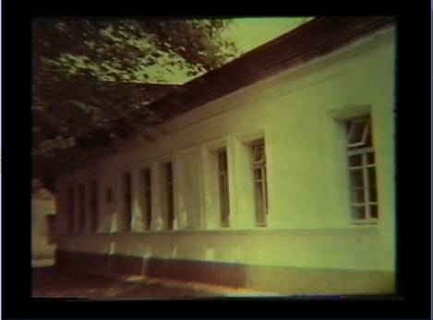
Дом общественного собрания
ENGLISH House of Public Meeting
﻿ House of Public Meeting on Bazarnaya Street A large one-story brick house, completely plastered. Simple window openings on smooth wall facades are complemented by straight sandstones. The house had spacious rooms. The Public Assembly met there. After the revolution of 1917, it housed the executive committee of the Pishpek district Council of Workers', Soldiers' and Peasants' Deputies.
Source: https://bimap.su/description/pishpek/192_Sobranie.txt · BIMAP
Фотографии и материалы принадлежат их авторам; лицензия не указана

FRUNZE
No information has been found for this period yet
42.88317, 74.61200

Фотография пока не добавлена
ENGLISH
No information has been found for this period yet.

BISHKEK
No information has been found for this period yet
42.88317, 74.61200

Фотография пока не добавлена
ENGLISH
No information has been found for this period yet.

