PISHPEK
Mosque on Uyezdnaya Street
42.87900, 74.61309
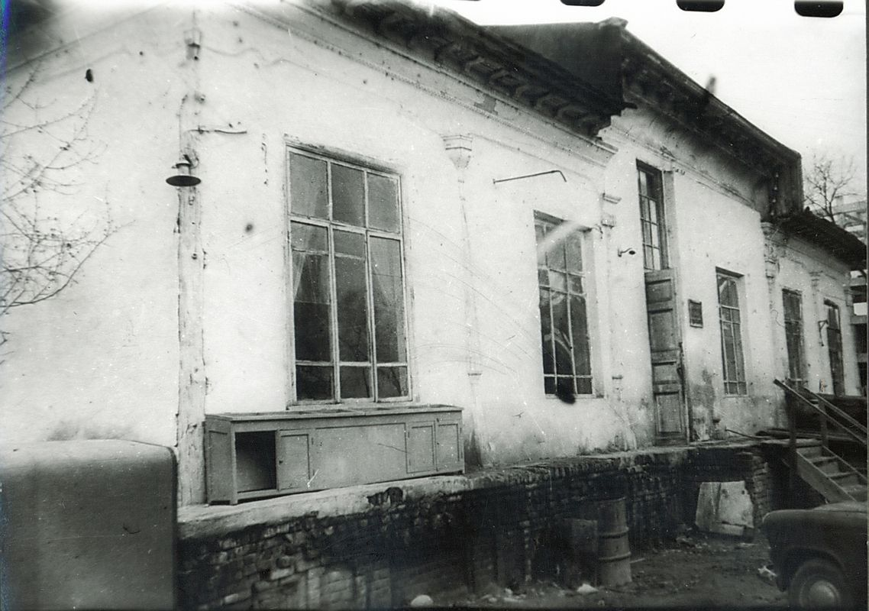
Мечеть на улице Уездной
ENGLISH Mosque on Uyezdnaya Street
﻿ Mosque on Uyezdnaya Street The mosque on Uyezdnaya Street was distinguished by its magnificent ornamental painting and elegant ganch sculpting. The open veranda and pointed roof were decorated with wood carvings. In the photograph, fragments of the old building are still visible in its later reconstruction. At one time, this building housed a puppet theater, then theater workshops, which burned down on the May Day holidays of 1965.
Source: https://bimap.su/description/pishpek/191_Mechet.txt · BIMAP
Фотографии и материалы принадлежат их авторам; лицензия не указана

FRUNZE
No information has been found for this period yet
42.87900, 74.61309

Фотография пока не добавлена
ENGLISH
No information has been found for this period yet.

BISHKEK
No information has been found for this period yet
42.87900, 74.61309

Фотография пока не добавлена
ENGLISH
No information has been found for this period yet.

