PISHPEK
Beginning of construction of the House of Printing
42.87490, 74.60711
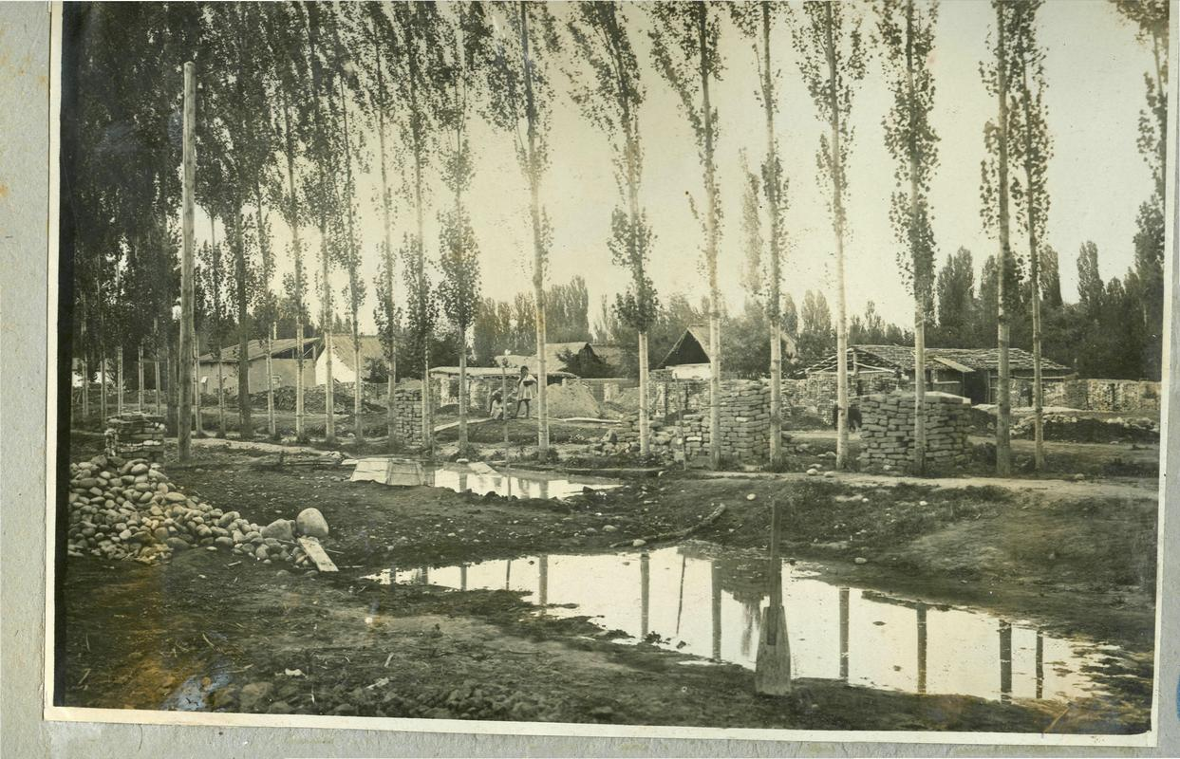
Начало строительства Дома Печати
ENGLISH Beginning of construction of the House of Printing
﻿ Beginning of construction of the House of Printing, 1930. This is what Dunganskaya Street looked like at the intersection with Boulevard before the start of construction of the House of Printing.
Source: https://bimap.su/description/pishpek/190_Dunganskaia.txt · BIMAP
Фотографии и материалы принадлежат их авторам; лицензия не указана

FRUNZE
No information has been found for this period yet
42.87490, 74.60711

Фотография пока не добавлена
ENGLISH
No information has been found for this period yet.

BISHKEK
No information has been found for this period yet
42.87490, 74.60711

Фотография пока не добавлена
ENGLISH
No information has been found for this period yet.

