PISHPEK
Dungan Cemetery
42.88200, 74.56476
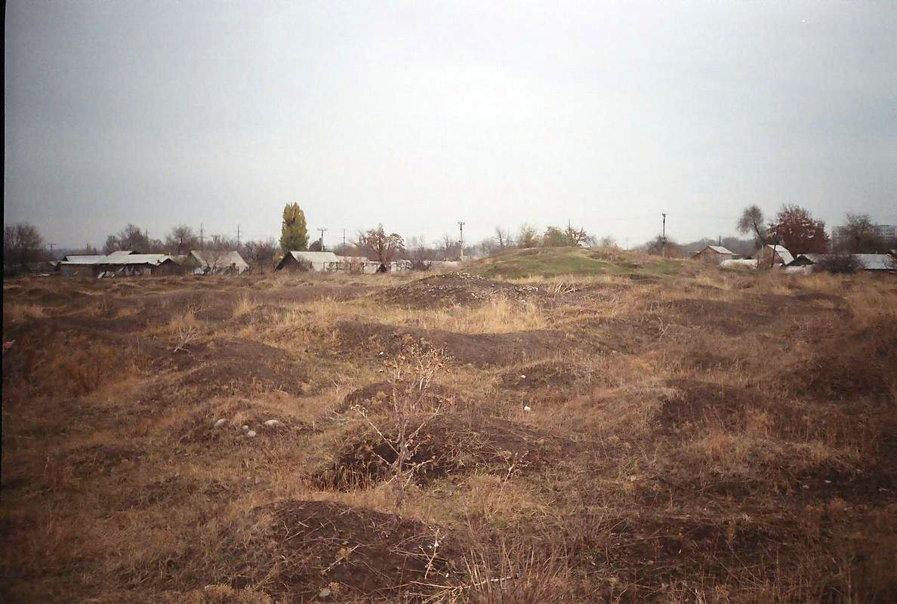
Дунганское кладбище
ENGLISH Dungan Cemetery
﻿ Old Dungan Cemetery Buried in the unmarked graves of the Dungan Cemetery are: Saint Lintao Lozhen, Wang Dage - hero of the Russo-Japanese War, full Knight of St. George, Bai Yanhu (presumably) - leader of the Dungan uprising in Northwestern China, died in Pishpek in 1882 year.
Source: https://bimap.su/description/pishpek/189_Kladbische.txt · BIMAP
Фотографии и материалы принадлежат их авторам; лицензия не указана

FRUNZE
No information has been found for this period yet
42.88200, 74.56476

Фотография пока не добавлена
ENGLISH
No information has been found for this period yet.

BISHKEK
No information has been found for this period yet
42.88200, 74.56476

Фотография пока не добавлена
ENGLISH
No information has been found for this period yet.

