PISHPEK
The intersection of Konstantinovskaya and Tatarskaya streets
42.87898, 74.59398
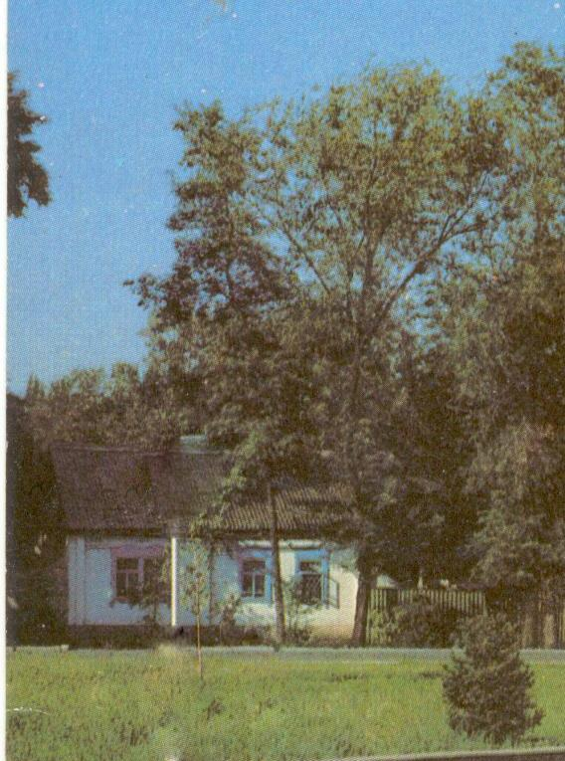
Пересечение улиц Константиновская и Татарская
ENGLISH The intersection of Konstantinovskaya and Tatarskaya streets
﻿ Konstantinovskaya x Tatarskaya The end of the 19th - beginning of the 20th centuries is characterized by the improvement of the city and the construction of large houses at the head of the city estate. The houses stood on high stone foundations made of cobblestones or ashlars, above which there was a brick basement of the semi-basement or first floor with patterned decor of the brickwork. The walls could have been adobe. The number of rooms was
Source: https://bimap.su/description/pishpek/186_Konstantinovskaia.txt · BIMAP
Фотографии и материалы принадлежат их авторам; лицензия не указана

FRUNZE
No information has been found for this period yet
42.87898, 74.59398

Фотография пока не добавлена
ENGLISH
No information has been found for this period yet.

BISHKEK
No information has been found for this period yet
42.87898, 74.59398

Фотография пока не добавлена
ENGLISH
No information has been found for this period yet.

