PISHPEK
House on Gryaznovskaya Street
42.87204, 74.60162
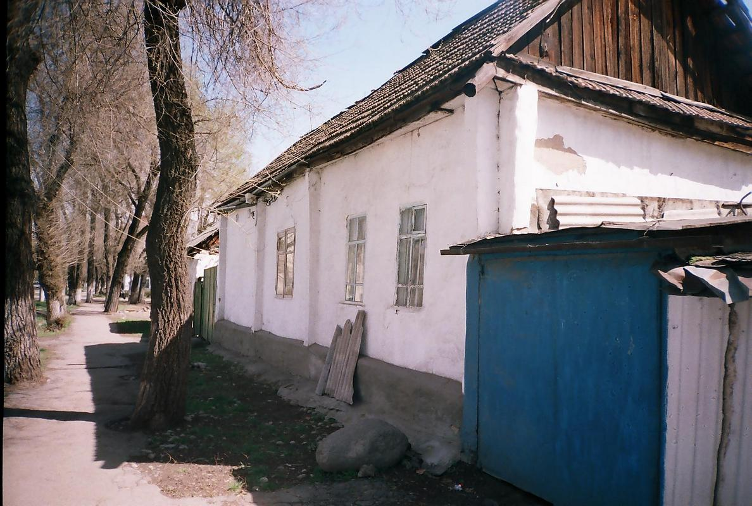
Дом по улице Грязновской
ENGLISH House on Gryaznovskaya Street
﻿ House on Gryaznovskaya Street One of the first houses of Pishpek. On a stone foundation there are log walls made of hewn logs. There are two rooms with a hallway and a kitchen in the middle. The facade of the house and the console are plastered and decorated with simple sawn cornices and platbands. The late tiled roof most likely replaced a reed or plank roof.
Source: https://bimap.su/description/pishpek/181_Dom_na_Griaznovskoi.txt · BIMAP
Фотографии и материалы принадлежат их авторам; лицензия не указана

FRUNZE
No information has been found for this period yet
42.87204, 74.60162

Фотография пока не добавлена
ENGLISH
No information has been found for this period yet.

BISHKEK
No information has been found for this period yet
42.87204, 74.60162

Фотография пока не добавлена
ENGLISH
No information has been found for this period yet.

