PISHPEK
House on Konstantinovskaya Street
42.87395, 74.59351
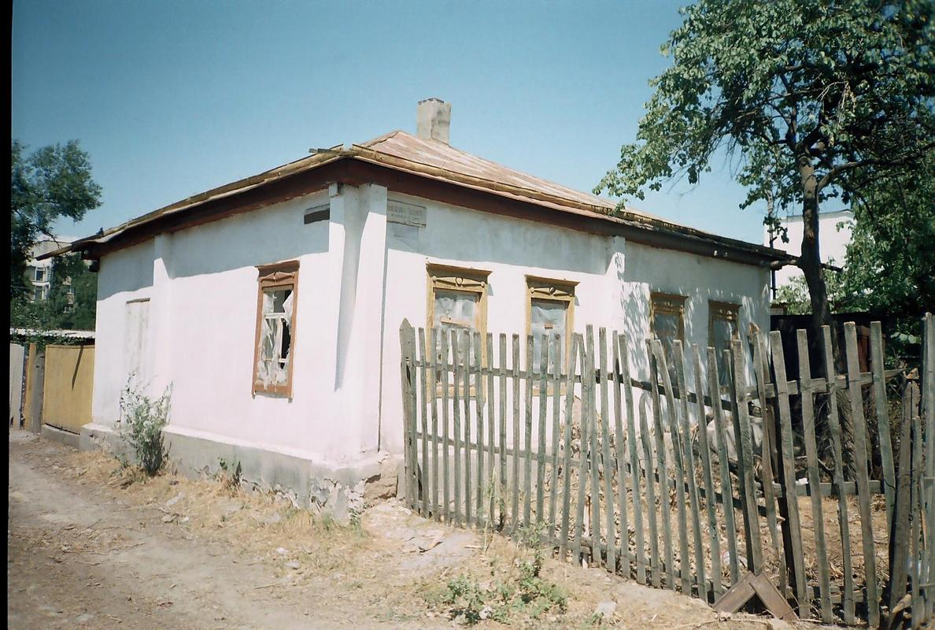
Дом по улице Константиновской · Денисова
ENGLISH House on Konstantinovskaya Street
House on Konstantinovskaya Street, corner of Soldatskaya The end of the 19th - beginning of the 20th centuries is characterized by the improvement of the city and the construction of large houses at the head of the city estate. The houses stood on high stone foundations made of cobblestones or ashlars, above which there was a brick basement of the semi-basement or first floor with patterned decor of the brickwork. The roofs of rich buildings were
Source: https://bimap.su/description/pishpek/179_Dom_na_Konstantinovskoi.txt · BIMAP
Фотографии и материалы принадлежат их авторам; лицензия не указана

FRUNZE
No information has been found for this period yet
42.87395, 74.59351

Фотография пока не добавлена
ENGLISH
No information has been found for this period yet.

BISHKEK
No information has been found for this period yet
42.87395, 74.59351

Фотография пока не добавлена
ENGLISH
No information has been found for this period yet.

