PISHPEK
Houses on Tashkentskaya street
42.88422, 74.60877
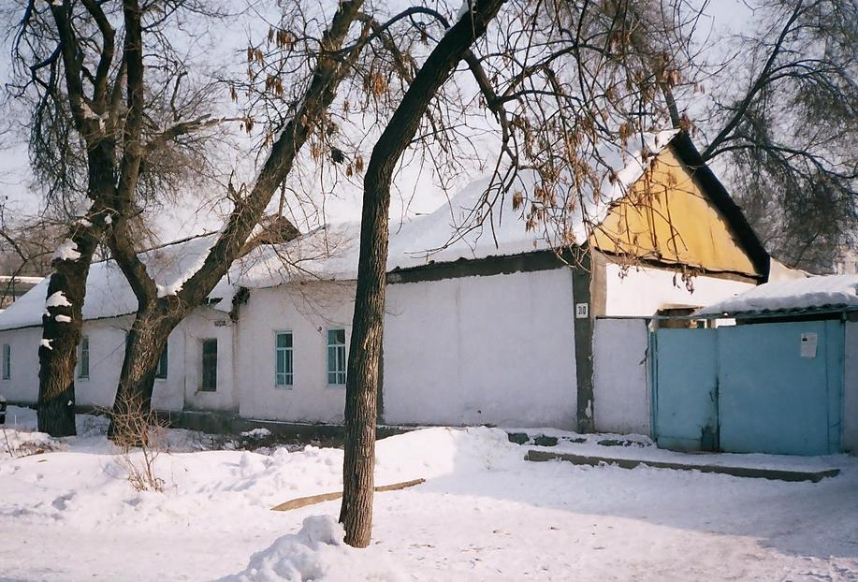
Дома по улице Ташкентской
ENGLISH Houses on Tashkentskaya street
﻿ Houses on Tashkentskaya between Pushchinskaya and Boulevard The initial construction of houses in the city took place spontaneously - near the ruined fortress, along the Tashkent highway and the Alamedin River channel, so the streets of this area adjoin obliquely to the rectilinear streets of later planned development. This part of the city consisted of small clay buildings with reed roofs, whitewashed walls and courtyards hidden behind blind c
Source: https://bimap.su/description/pishpek/174_Doma_na_Tashkentskoi.txt · BIMAP
Фотографии и материалы принадлежат их авторам; лицензия не указана

FRUNZE
No information has been found for this period yet
42.88422, 74.60877

Фотография пока не добавлена
ENGLISH
No information has been found for this period yet.

BISHKEK
No information has been found for this period yet
42.88422, 74.60877

Фотография пока не добавлена
ENGLISH
No information has been found for this period yet.

