PISHPEK
House on the corner of Petrovskaya and Tatarskaya streets
42.87869, 74.57943
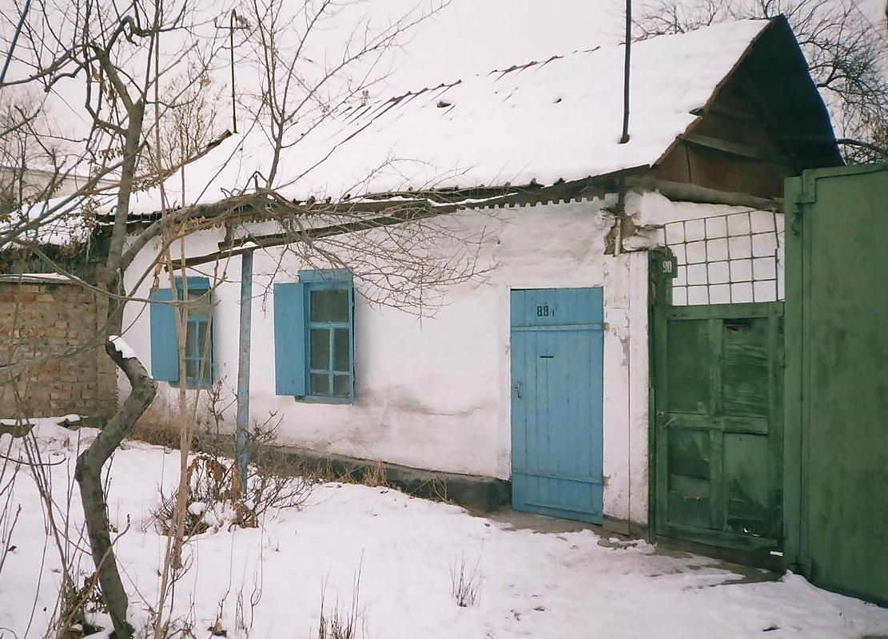
Дом на углу улиц Петровской и Татарской · Никиты Часова
ENGLISH House on the corner of Petrovskaya and Tatarskaya streets
﻿ House on the corner of Petrovskaya and Tatarskaya streets In 1882, a large group of Dungan refugees from China arrived in Pishpek. They were accepted into Russian citizenship and settled compactly on the western outskirts of the city of Pishkek, forming the so-called Dungan settlement. Dungan estates were located here freely, as was always done in Dungan settlements, and all undeveloped space was occupied by fields and vegetable gardens. But th
Source: https://bimap.su/description/pishpek/173_Dom_na_Petrovskoi.txt · BIMAP
Фотографии и материалы принадлежат их авторам; лицензия не указана

FRUNZE
No information has been found for this period yet
42.87869, 74.57943

Фотография пока не добавлена
ENGLISH
No information has been found for this period yet.

BISHKEK
No information has been found for this period yet
42.87869, 74.57943

Фотография пока не добавлена
ENGLISH
No information has been found for this period yet.

