PISHPEK
Mosque in Dunganovka
42.87710, 74.58867
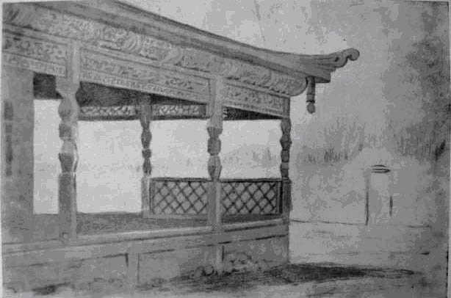
Мечеть в Дунгановке
ENGLISH Mosque in Dunganovka
﻿ Mosque in Dunganovka. From a drawing by B. Smirnov, 1906. There were twenty mosques and houses of worship in the city. The Dungan mosque on Klyuchevaya differed from others in its elegance. The open veranda and pointed roof were decorated with wood carvings. In 1918, during the Belovodsk rebellion, the majority of the Pishpek Dungans took the side of the rebels. The suppression of the rebels was particularly brutal. Participants in the hostilit
Source: https://bimap.su/description/pishpek/171_Dunganskaia_mechet.txt · BIMAP
Фотографии и материалы принадлежат их авторам; лицензия не указана

FRUNZE
No information has been found for this period yet
42.87710, 74.58867

Фотография пока не добавлена
ENGLISH
No information has been found for this period yet.

BISHKEK
No information has been found for this period yet
42.87710, 74.58867

Фотография пока не добавлена
ENGLISH
No information has been found for this period yet.

