PISHPEK
House on the corner of Kupecheskaya and Boulevard streets
42.87560, 74.60586
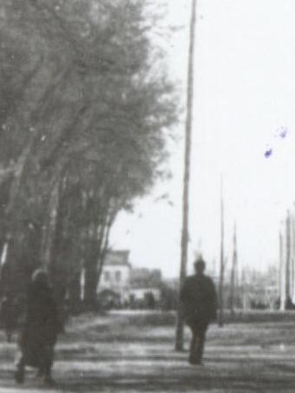
Дом на углу улиц Купеческой и Бульварной
ENGLISH House on the corner of Kupecheskaya and Boulevard streets
﻿ House on the corner of Kupecheskaya and Boulevard streets The end of the 19th - beginning of the 20th centuries is characterized by the improvement of the city and the construction of large houses at the head of the city estate. The houses stood on high stone foundations made of cobblestones or ashlars, above which there was a brick basement of the semi-basement or first floor with patterned decor of the brickwork. The roofs of rich buildings w
Source: https://bimap.su/description/pishpek/170_Dom_na_Bulvarnoi1928.txt · BIMAP
Фотографии и материалы принадлежат их авторам; лицензия не указана

FRUNZE
No information has been found for this period yet
42.87560, 74.60586

Фотография пока не добавлена
ENGLISH
No information has been found for this period yet.

BISHKEK
No information has been found for this period yet
42.87560, 74.60586

Фотография пока не добавлена
ENGLISH
No information has been found for this period yet.

