PISHPEK
Salnikov's House
42.88001, 74.60291
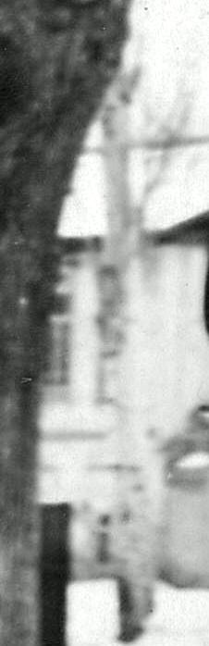
Дом Сальникова · Владимира Петрова
ENGLISH Salnikov's House
﻿ Salnikov's House. Beginning of the twentieth century. Demolished in the 60s. The end of the 19th and beginning of the 20th centuries was characterized by the improvement of the city and the construction of large houses at the head of the city estate. The houses stood on high stone foundations made of cobblestones or ashlars, above which there was a brick basement of the semi-basement or first floor with patterned decor of the brickwork. The roo
Source: https://bimap.su/description/pishpek/169_Dom_Salnikova.txt · BIMAP
Фотографии и материалы принадлежат их авторам; лицензия не указана

FRUNZE
No information has been found for this period yet
42.88001, 74.60291

Фотография пока не добавлена
ENGLISH
No information has been found for this period yet.

BISHKEK
No information has been found for this period yet
42.88001, 74.60291

Фотография пока не добавлена
ENGLISH
No information has been found for this period yet.

