PISHPEK
Houses on the western side of Bazarnaya street
42.88535, 74.61144
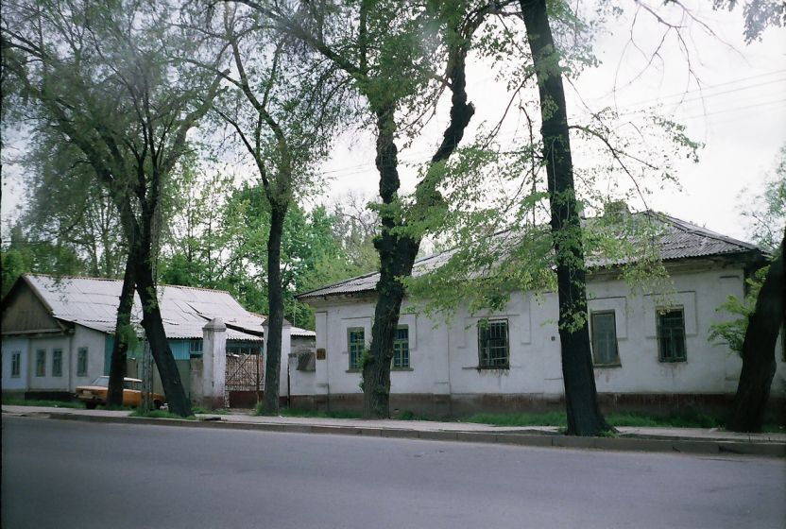
Дома на западной стороне улицы Базарной · Владимира Петрова
ENGLISH Houses on the western side of Bazarnaya street
﻿ Houses on the western side of Bazarnaya street below Tashkentskaya. The beginning of the 20th century The end of the 19th and beginning of the 20th centuries was characterized by the improvement of the city and the construction of large houses at the head of the city estate. The houses stood on high stone foundations made of cobblestones or ashlars, above which there was a brick basement of the semi-basement or first floor with patterned decor
Source: https://bimap.su/description/pishpek/168_Doma_na_Bazarnoi.txt · BIMAP
Фотографии и материалы принадлежат их авторам; лицензия не указана

FRUNZE
No information has been found for this period yet
42.88535, 74.61144

Фотография пока не добавлена
ENGLISH
No information has been found for this period yet.

BISHKEK
No information has been found for this period yet
42.88535, 74.61144

Фотография пока не добавлена
ENGLISH
No information has been found for this period yet.

