PISHPEK
House on Soldatskaya Street
42.87265, 74.61916
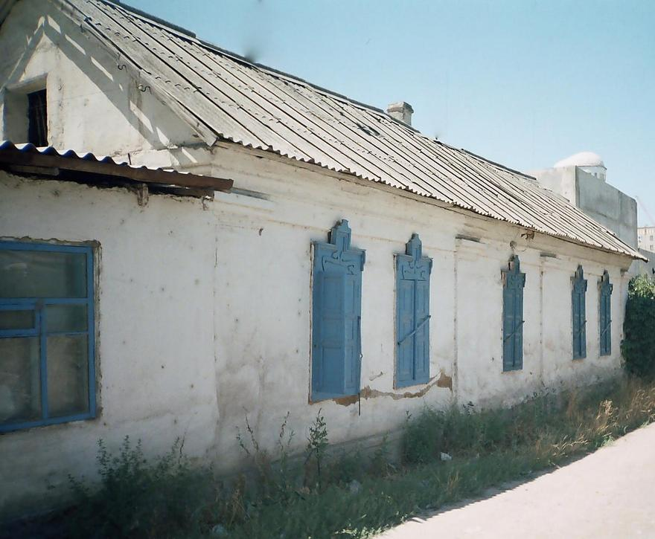
Дом на улице Солдатской · Никиты Часова
ENGLISH House on Soldatskaya Street
House on Soldatskaya The end of the 19th - beginning of the 20th centuries is characterized by the improvement of the city and the construction of large houses at the head of the city estate. The houses stood on high stone foundations made of cobblestones or ashlars, above which there was a brick basement of the semi-basement or first floor with patterned decor of the brickwork. The walls could be made of baked brick or adobe. The number of rooms
Source: https://bimap.su/description/pishpek/164_Dom_na_Kuznechnoi.txt · BIMAP
Фотографии и материалы принадлежат их авторам; лицензия не указана

FRUNZE
No information has been found for this period yet
42.87265, 74.61916

Фотография пока не добавлена
ENGLISH
No information has been found for this period yet.

BISHKEK
No information has been found for this period yet
42.87265, 74.61916

Фотография пока не добавлена
ENGLISH
No information has been found for this period yet.

