PISHPEK
House on Sudeyskaya Street
42.88199, 74.57747
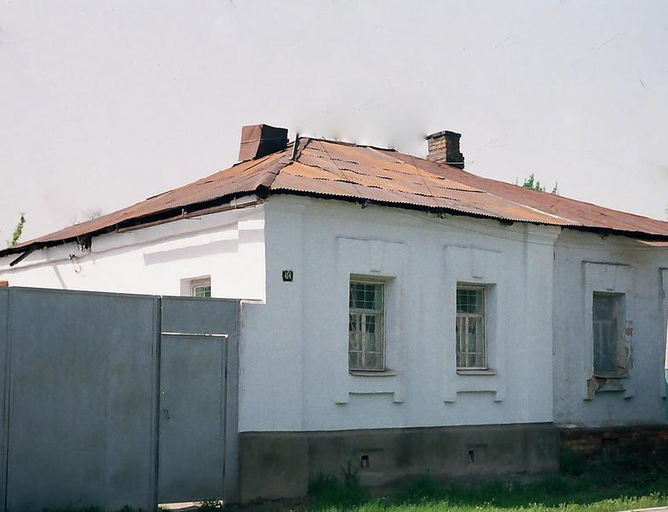
Дом по улице Судейской · Денисова
ENGLISH House on Sudeyskaya Street
﻿ House on Sudeyskaya Street east of Atbashinskaya. The beginning of the 20th century The end of the 19th and beginning of the 20th centuries was characterized by the improvement of the city and the construction of large houses at the head of the city estate. The houses stood on high stone foundations made of cobblestones or ashlars, above which there was a brick basement of the semi-basement or first floor with patterned decor of the brickwork.
Source: https://bimap.su/description/pishpek/163_Dom_na_Sudeiskoi.txt · BIMAP
Фотографии и материалы принадлежат их авторам; лицензия не указана

FRUNZE
No information has been found for this period yet
42.88199, 74.57747

Фотография пока не добавлена
ENGLISH
No information has been found for this period yet.

BISHKEK
No information has been found for this period yet
42.88199, 74.57747

Фотография пока не добавлена
ENGLISH
No information has been found for this period yet.

