PISHPEK
Horse-mounted postal station
42.88460, 74.61505
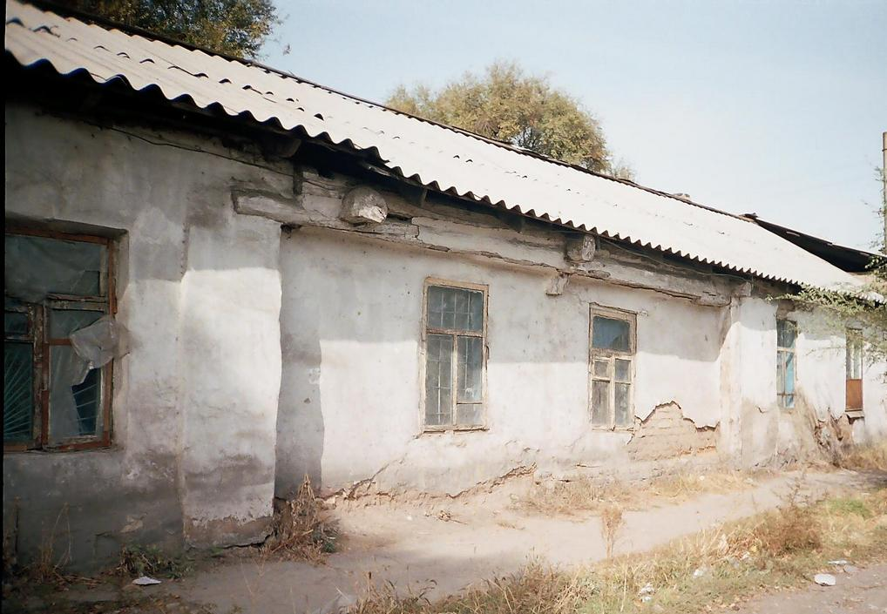
Конно-почтовая станция · Никиты Часова
ENGLISH Horse-mounted postal station
﻿ Horse-mounted postal station 1868 The beginning of postal communication in the region by wheeled tarantass carriages was laid in 1864. By order of the authorities, postal communication was a natural service of local residents and the maintenance of each postal station was entrusted to the head of a nearby nomadic Kyrgyz clan, who received horses, carts, harness and money for the maintenance of coachmen. But the carts and harness were soon destr
Source: https://bimap.su/description/pishpek/162_Konnaia_stancia_1868.txt · BIMAP
Фотографии и материалы принадлежат их авторам; лицензия не указана

FRUNZE
No information has been found for this period yet
42.88460, 74.61505

Фотография пока не добавлена
ENGLISH
No information has been found for this period yet.

BISHKEK
No information has been found for this period yet
42.88460, 74.61505

Фотография пока не добавлена
ENGLISH
No information has been found for this period yet.

