PISHPEK
Agricultural school building
42.84429, 74.60399
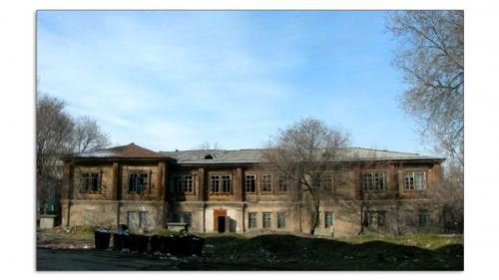
Здание сельхозшколы · Виктора Глумскова
ENGLISH Agricultural school building
﻿ Agricultural school building. Demolished in 2005 In 1889 A.M. Fetisov founded the Kyrgyz school of gardening. Its students were fully supported by funds raised by the Kyrgyz population. The main goal was for students to master gardening and vegetable gardening skills. The course of study at the school lasted three years. After Fetisov's death in 1894, the school was headed by Ilya Pavlovich Ivanov. Under him, the school and its garden were in e
Source: https://bimap.su/description/pishpek/159_Selhozshkola.txt · BIMAP
Фотографии и материалы принадлежат их авторам; лицензия не указана

FRUNZE
No information has been found for this period yet
42.84429, 74.60399

Фотография пока не добавлена
ENGLISH
No information has been found for this period yet.

BISHKEK
No information has been found for this period yet
42.84429, 74.60399

Фотография пока не добавлена
ENGLISH
No information has been found for this period yet.

