PISHPEK
Boulevard Street
42.87958, 74.60689
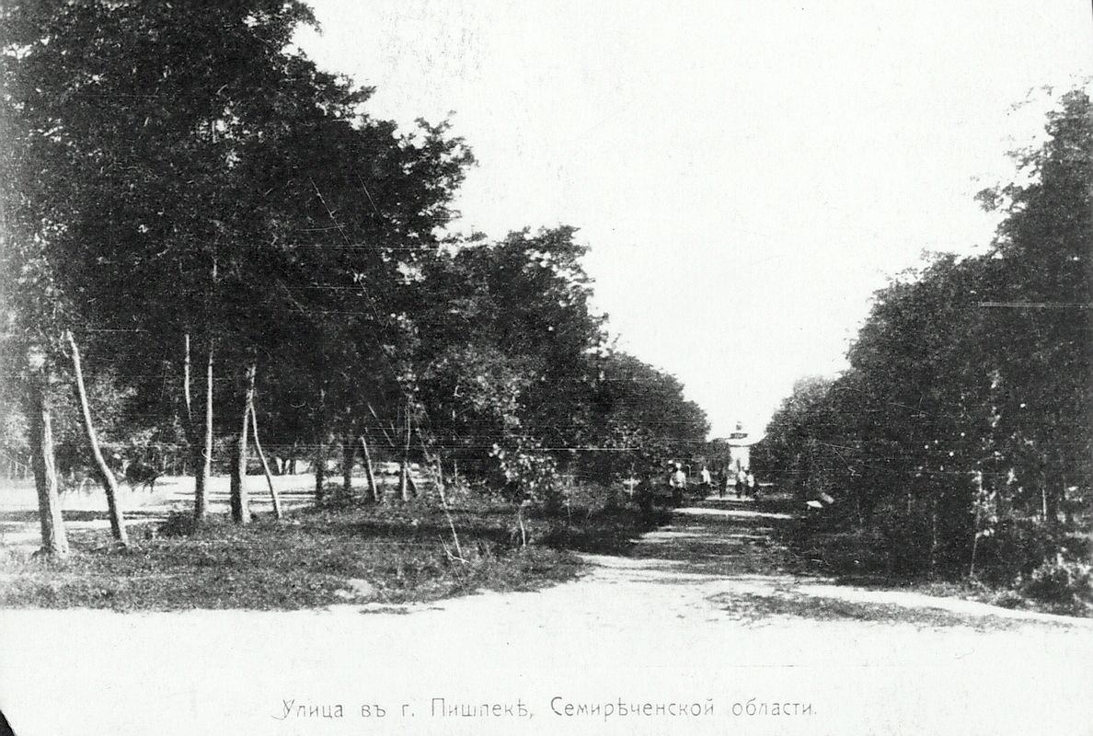
Улица Бульварная
ENGLISH Boulevard Street
﻿ Boulevard Street from the side of the street. District. Beginning of the 20th century Fetisov’s planting of the first silver poplars and oaks along the ditches near his house in 1879 gave rise to the city’s Boulevard Alley. On Forest Day, April 4, 1902, the plantings were extended to Verkhnyaya Street, although the annual rings on the stumps of the trees cut down here indicate that they were planted no later than 1893. The Tserkovny ditch, used
Source: https://bimap.su/description/pishpek/16_Bulvar.txt · BIMAP
Фотографии и материалы принадлежат их авторам; лицензия не указана

FRUNZE
No information has been found for this period yet
42.87958, 74.60689

Фотография пока не добавлена
ENGLISH
No information has been found for this period yet.

BISHKEK
No information has been found for this period yet
42.87958, 74.60689

Фотография пока не добавлена
ENGLISH
No information has been found for this period yet.

