PISHPEK
House of the bailiff Gribanovsky
42.87112, 74.60266
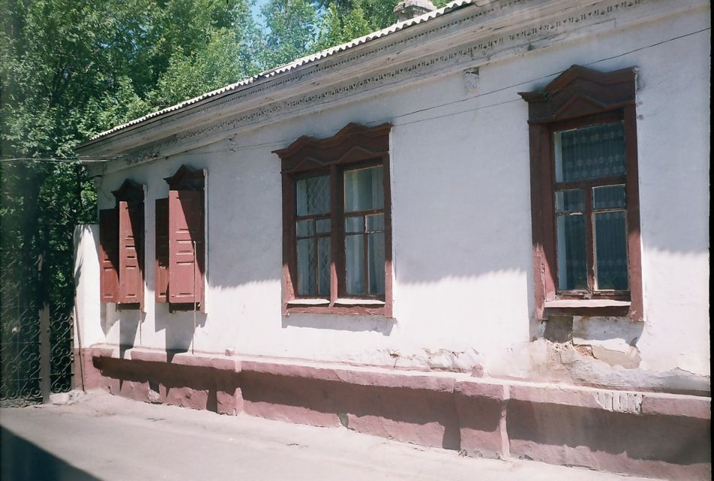
Дом пристава Грибановского · Владимира Петрова
ENGLISH House of the bailiff Gribanovsky
﻿ House of the bailiff Gribanovsky on Meshchanskaya corner of Novaya The end of the 19th - beginning of the 20th centuries is characterized by the improvement of the city and the construction of significant houses at the head of the city estate. The houses stood on high stone foundations made of cobblestones or ashlars, above which there was a brick basement of the semi-basement or first floor with patterned decor of the brickwork. The walls are
Source: https://bimap.su/description/pishpek/156_Dom_Gribanovskova.txt · BIMAP
Фотографии и материалы принадлежат их авторам; лицензия не указана

FRUNZE
No information has been found for this period yet
42.87112, 74.60266

Фотография пока не добавлена
ENGLISH
No information has been found for this period yet.

BISHKEK
No information has been found for this period yet
42.87112, 74.60266

Фотография пока не добавлена
ENGLISH
No information has been found for this period yet.

