PISHPEK
House on Kupecheskaya Street under a reed roof
42.87572, 74.61634
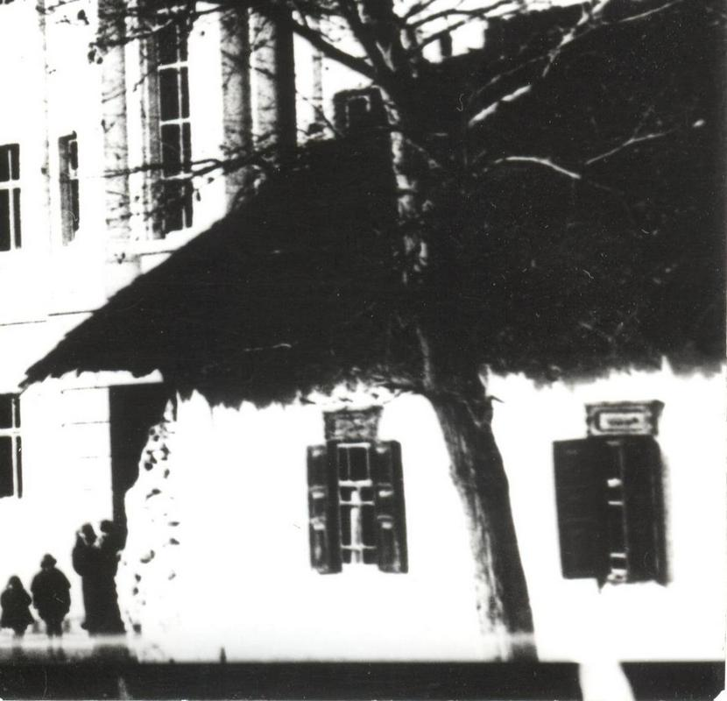
Дом по улице Купеческой под камышевой крышей
ENGLISH House on Kupecheskaya Street under a reed roof
﻿ House under a reed roof on Kupecheskaya Houses on courtyard estates were placed on the corner or in the center of the site, with the main facades facing the street. Basically, the city consisted of one-story buildings with reed roofs, whitewashed walls and courtyards hidden behind blind clay fences, or fenced with wooden palisades or wattle fences. In the courtyards, utility rooms were indispensable: summer kitchens, sheds, cellars, stalls.
Source: https://bimap.su/description/pishpek/149_Dom_na_Kupecheskoi.txt · BIMAP
Фотографии и материалы принадлежат их авторам; лицензия не указана

FRUNZE
No information has been found for this period yet
42.87572, 74.61634

Фотография пока не добавлена
ENGLISH
No information has been found for this period yet.

BISHKEK
No information has been found for this period yet
42.87572, 74.61634

Фотография пока не добавлена
ENGLISH
No information has been found for this period yet.

