PISHPEK
House on Iskakovskaya street
42.86907, 74.62173
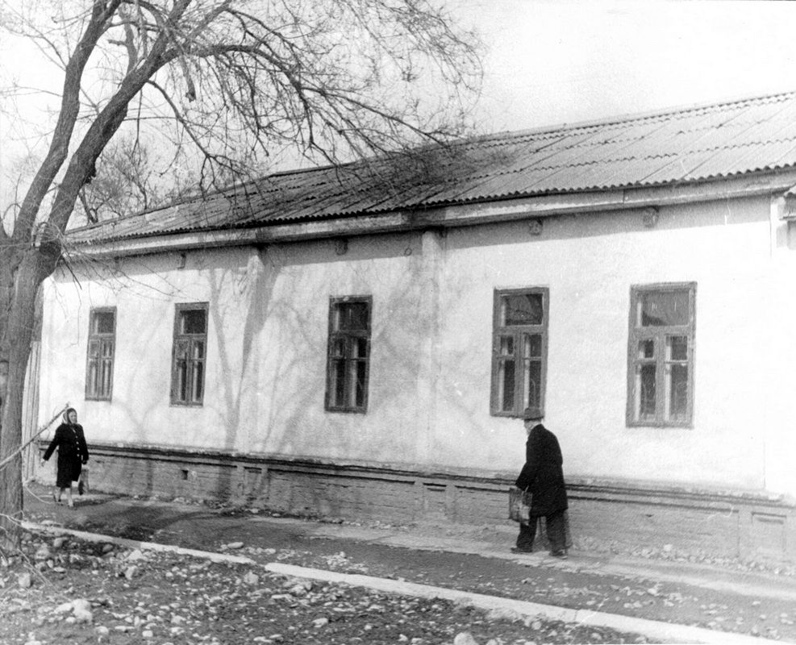
Дом по улице Искаковской
ENGLISH House on Iskakovskaya street
﻿ House on Iskakovskaya street next to the mosque. Early 20th century House of a wealthy citizen. The end of the 19th and beginning of the 20th centuries was characterized by the improvement of the city and the construction of large houses at the head of the city estate. The houses stood on high stone foundations made of cobblestones or ashlars, above which there was a brick basement with a patterned decor of the brickwork. The walls are frame-wo
Source: https://bimap.su/description/pishpek/148_Dom_na_Iskakovskoi.txt · BIMAP
Фотографии и материалы принадлежат их авторам; лицензия не указана

FRUNZE
No information has been found for this period yet
42.86907, 74.62173

Фотография пока не добавлена
ENGLISH
No information has been found for this period yet.

BISHKEK
No information has been found for this period yet
42.86907, 74.62173

Фотография пока не добавлена
ENGLISH
No information has been found for this period yet.

