PISHPEK
House on Klyuchevaya Street
42.88118, 74.58900
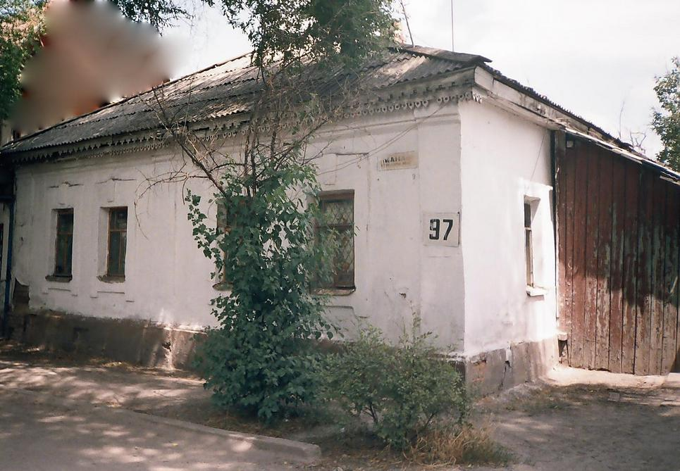
Дом по улице Ключевой · Никиты Часова
ENGLISH House on Klyuchevaya Street
﻿ House on Klyuchevaya Street. The beginning of the twentieth century The city expanded and the rectilinear layout affected the chaotically built-up Dunganovka. Many residents could not withstand the onslaught of “urbanization”, sold their plots and moved to the countryside. Others became merchants and industrialists and built planned houses even in the central part of the city. So Lulosa Motanyu and his brother Yusuz had a number of shops, rice
Source: https://bimap.su/description/pishpek/147_Dom_na_Kluchevoi.txt · BIMAP
Фотографии и материалы принадлежат их авторам; лицензия не указана

FRUNZE
No information has been found for this period yet
42.88118, 74.58900

Фотография пока не добавлена
ENGLISH
No information has been found for this period yet.

BISHKEK
No information has been found for this period yet
42.88118, 74.58900

Фотография пока не добавлена
ENGLISH
No information has been found for this period yet.

