PISHPEK
House on Tashkentskaya Street
42.88460, 74.60550
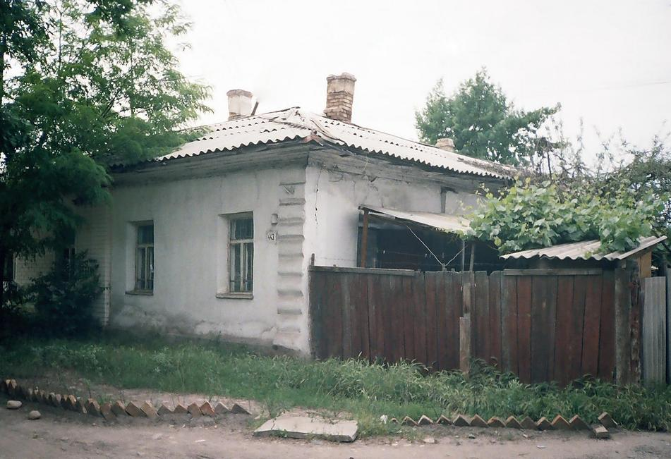
Дом по улице Ташкентской
ENGLISH House on Tashkentskaya Street
﻿ House on Tashkentskaya Street, west of Boulevard. End of the 19th century One of the first houses of Pishpek, built next to the fortress near the Tashkent highway. The walls are made of hewn logs. There are two rooms with a hallway and a kitchen in the middle. The facade of the house is plastered and decorated with simple cornices, platbands and shutters. The iron roof most likely replaced a reed or plank roof.
Source: https://bimap.su/description/pishpek/142_Dom_na_Tashkentskoi.txt · BIMAP
Фотографии и материалы принадлежат их авторам; лицензия не указана

FRUNZE
No information has been found for this period yet
42.88460, 74.60550

Фотография пока не добавлена
ENGLISH
No information has been found for this period yet.

BISHKEK
No information has been found for this period yet
42.88460, 74.60550

Фотография пока не добавлена
ENGLISH
No information has been found for this period yet.

