PISHPEK
Dubinin's House
42.88455, 74.60282
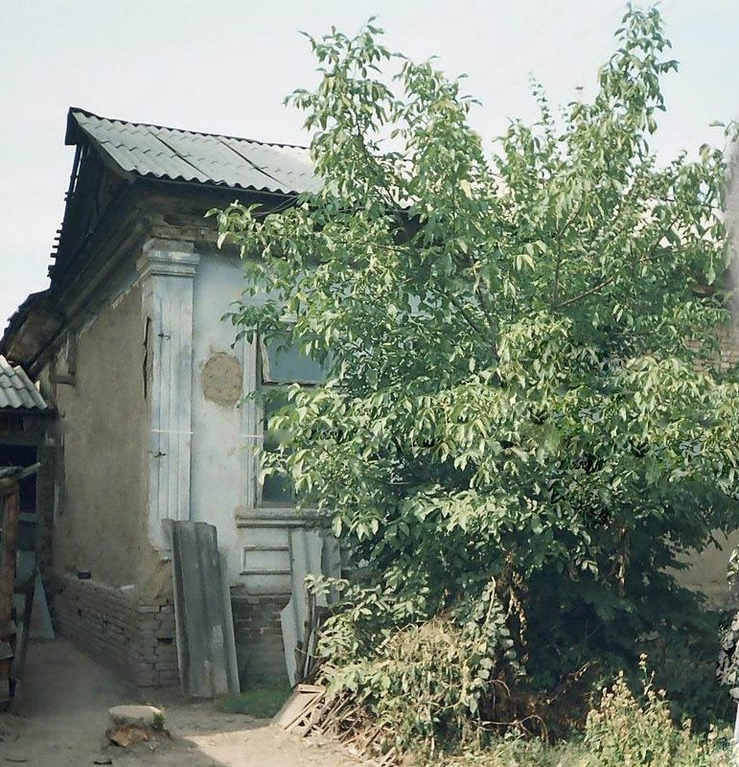
Дом Дубинина
ENGLISH Dubinin's House
﻿ House of the head of the post office Dubinin The officials who managed the post and telegraph office were among the leading people of the county. Dubinin Vladimir (Vasily) Ivanovich was the head of the Pishpek postal and telegraph office, when it was located on Tashkent near the destroyed fortress, he kept a hop plantation.
Source: https://bimap.su/description/pishpek/138_Dom_Dubinina.txt · BIMAP
Фотографии и материалы принадлежат их авторам; лицензия не указана

FRUNZE
No information has been found for this period yet
42.88455, 74.60282

Фотография пока не добавлена
ENGLISH
No information has been found for this period yet.

BISHKEK
No information has been found for this period yet
42.88455, 74.60282

Фотография пока не добавлена
ENGLISH
No information has been found for this period yet.

