PISHPEK
House on the corner of Shamuzinskaya and Tashkentskaya streets
42.88394, 74.58416
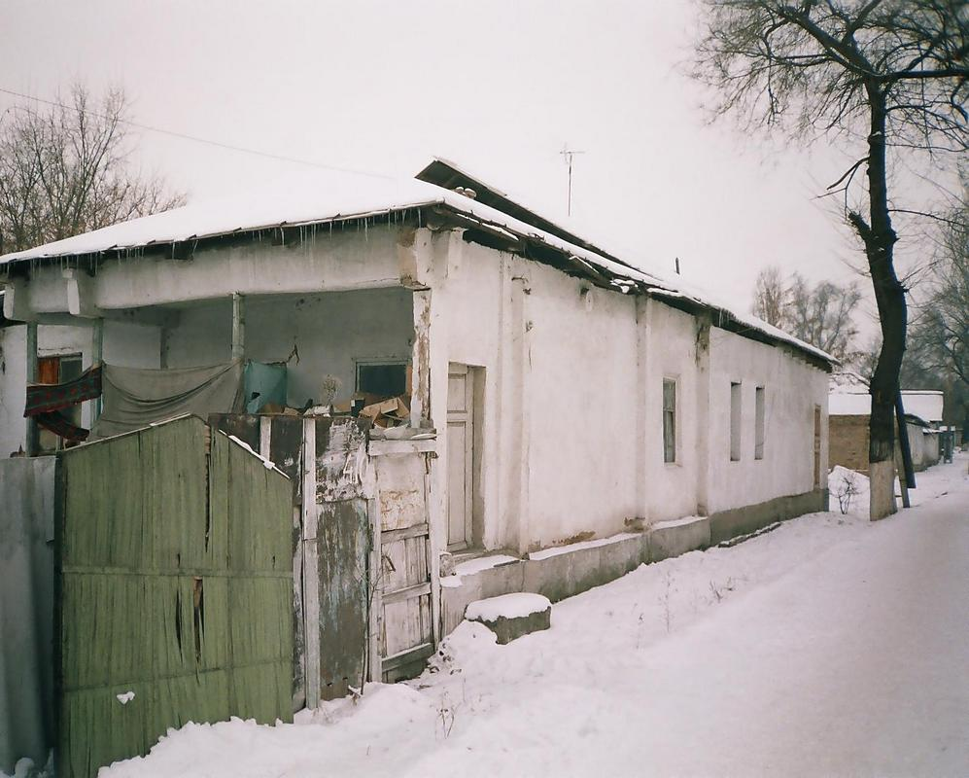
Дом на углу улиц Шамузинской и Ташкентской
ENGLISH House on the corner of Shamuzinskaya and Tashkentskaya streets
﻿ House on the corner of Shamuzinskaya and Tashkentskaya streets A house that has largely lost its original appearance. The house was made of wood frames with an internal veranda with an entrance from the street. The porch with its canopy and wooden railings and steps was gone. There are also no cornices, trims or shutters.
Source: https://bimap.su/description/pishpek/137_Shamuzinskaia_Tashkentskaia.txt · BIMAP
Фотографии и материалы принадлежат их авторам; лицензия не указана

FRUNZE
No information has been found for this period yet
42.88394, 74.58416

Фотография пока не добавлена
ENGLISH
No information has been found for this period yet.

BISHKEK
No information has been found for this period yet
42.88394, 74.58416

Фотография пока не добавлена
ENGLISH
No information has been found for this period yet.

