PISHPEK
House at the intersection of Tokmakskaya and Pushchinskaya streets
42.88211, 74.60946
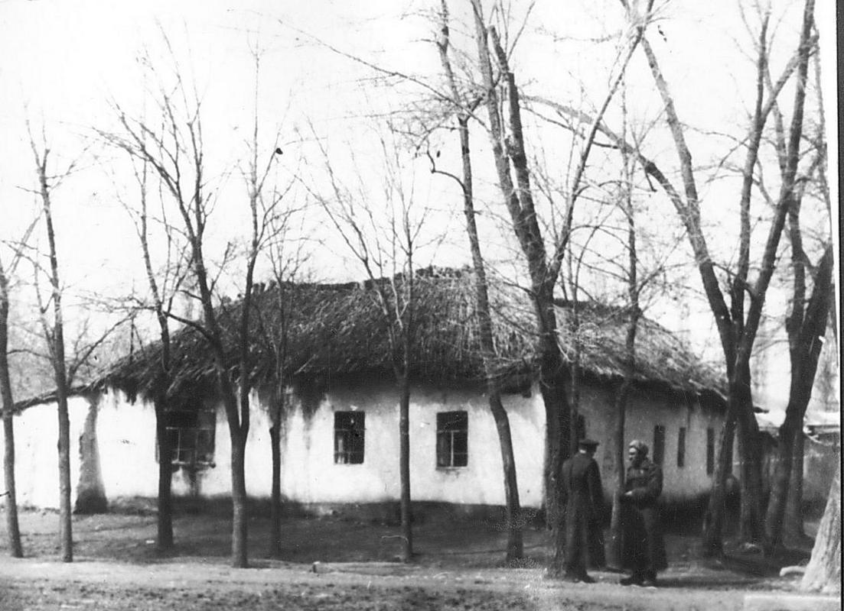
Дом на пересечении улиц Токмакской и Пущинской
ENGLISH House at the intersection of Tokmakskaya and Pushchinskaya streets
﻿ House at the intersection of Tokmakskaya and Pushchinskaya One of the typical houses of old Pishpek under a reed roof. This photograph was taken in the 60s of the twentieth century, which dramatized the situation during the October Revolution. Actors dressed for that time portrayed Bolsheviks near the house in which the revolutionary Ivanitsyn allegedly lived, after whom Tokmakskaya Street was named.
Source: https://bimap.su/description/pishpek/135_Tokmakcraia_Putchinskaia.txt · BIMAP
Фотографии и материалы принадлежат их авторам; лицензия не указана

FRUNZE
No information has been found for this period yet
42.88211, 74.60946

Фотография пока не добавлена
ENGLISH
No information has been found for this period yet.

BISHKEK
No information has been found for this period yet
42.88211, 74.60946

Фотография пока не добавлена
ENGLISH
No information has been found for this period yet.

