PISHPEK
House on the corner of Georgievskaya and Uezdnaya streets
42.88040, 74.59236
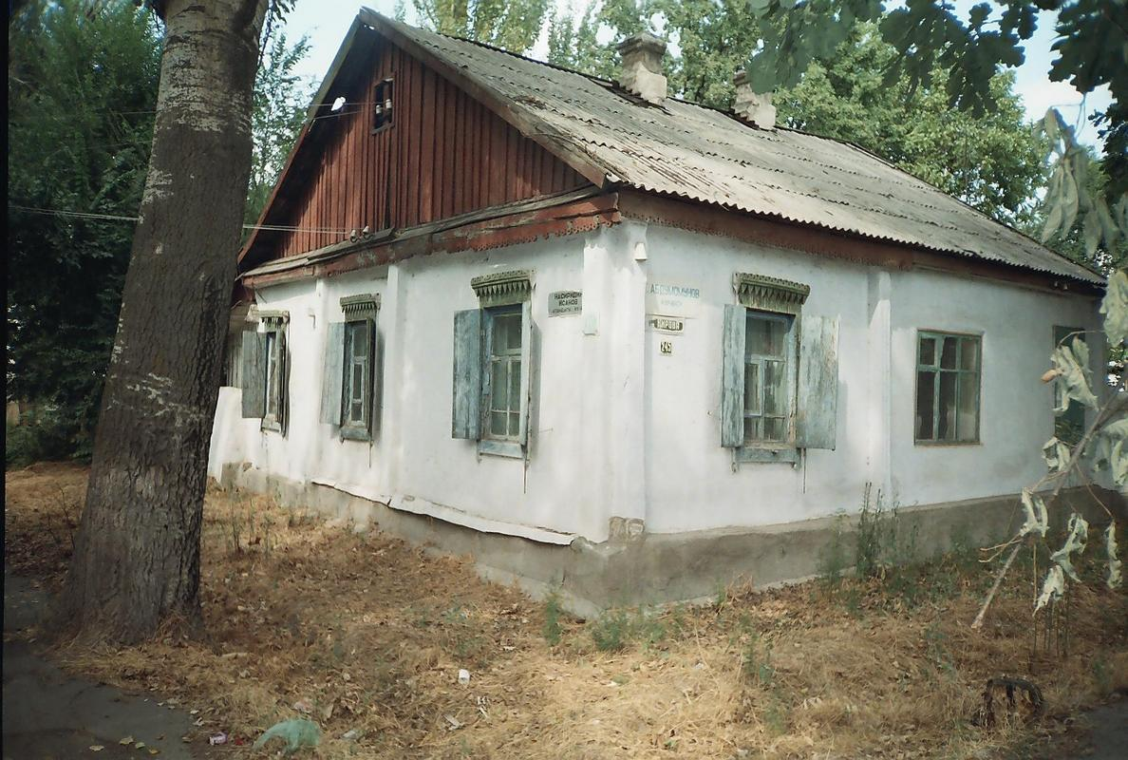
Дом на углу улиц Георгиевской и Уездной · Никиты Часова
ENGLISH House on the corner of Georgievskaya and Uezdnaya streets
﻿ House on the corner of Georgievskaya and Uezdnaya streets. Beginning of the 20th century In 1882, a large group of Dungan refugees from China arrived in Pishpek. They were accepted into Russian citizenship and settled compactly on the western outskirts of the city of Pishkek, forming the so-called Dungan settlement. Dungan estates were located here freely, as was always done in Dungan settlements, and all undeveloped space was occupied by field
Source: https://bimap.su/description/pishpek/132_Ugol_Georgievskoi_i_Uezdnoi.txt · BIMAP
Фотографии и материалы принадлежат их авторам; лицензия не указана

FRUNZE
No information has been found for this period yet
42.88040, 74.59236

Фотография пока не добавлена
ENGLISH
No information has been found for this period yet.

BISHKEK
No information has been found for this period yet
42.88040, 74.59236

Фотография пока не добавлена
ENGLISH
No information has been found for this period yet.

