PISHPEK
Bank building
42.88131, 74.60748
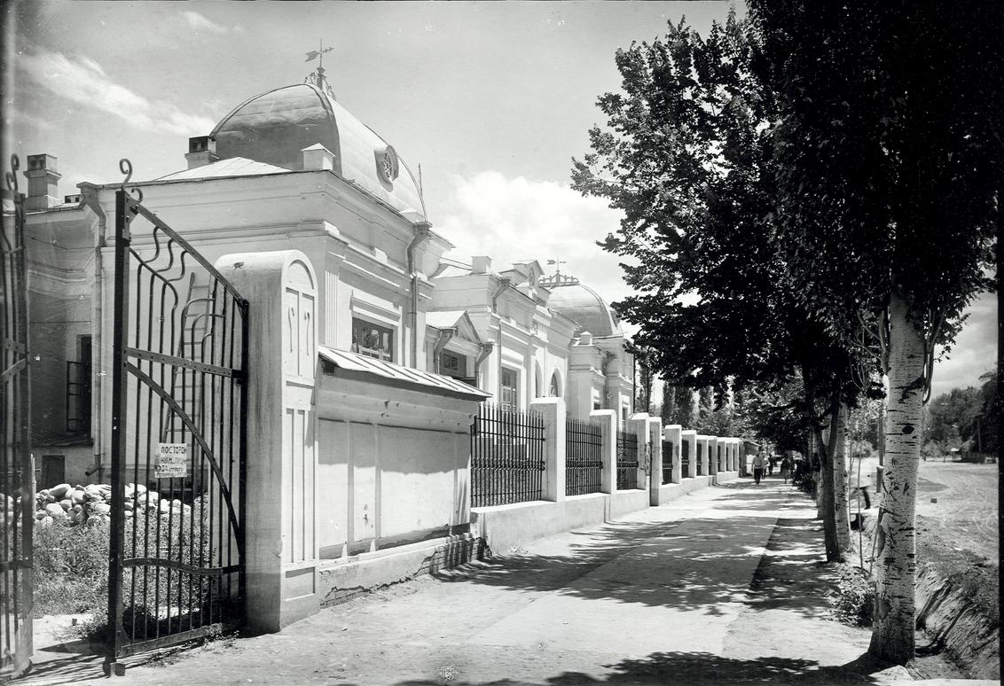
Здание банка
ENGLISH Bank building
﻿ Bank building on Boulevard The history of the city of Pishpek ends with the construction of several significant buildings in the city designed by architect Andrei Pavlovich Zenkov. Only three of the five buildings built by Zenkov have survived to this day: the Assembly of the People of Kyrgyzstan, the surgical center of the national hospital, and the bank on Erkindyk Avenue. And today, among the modern buildings of the city, they stand out for
Source: https://bimap.su/description/pishpek/13_Bank.txt · BIMAP
Фотографии и материалы принадлежат их авторам; лицензия не указана

FRUNZE
Bank building on Boulevard
42.88131, 74.60748
Здание банка на Бульварной
ENGLISH Bank building on Boulevard
﻿ Bank building on Boulevard. Architect A.P. Zenkov, 1928 The history of the city of Pishpek ends with the construction of several significant buildings in the city designed by architect Andrei Pavlovich Zenkov. Only three of the five buildings built by Zenkov have survived to this day: the Assembly of the People of Kyrgyzstan, the surgical center of the national hospital, and the bank on Erkindyk Avenue. And today, among the modern buildings of
Source: https://bimap.su/description/frunze/88_Bank.txt · BIMAP
Фотографии и материалы принадлежат их авторам; лицензия не указана

BISHKEK
No information has been found for this period yet
42.88131, 74.60748

Фотография пока не добавлена
ENGLISH
No information has been found for this period yet.

