PISHPEK
House at the intersection of Konstantinovskaya and Gryaznovskaya streets.
42.87230, 74.59338
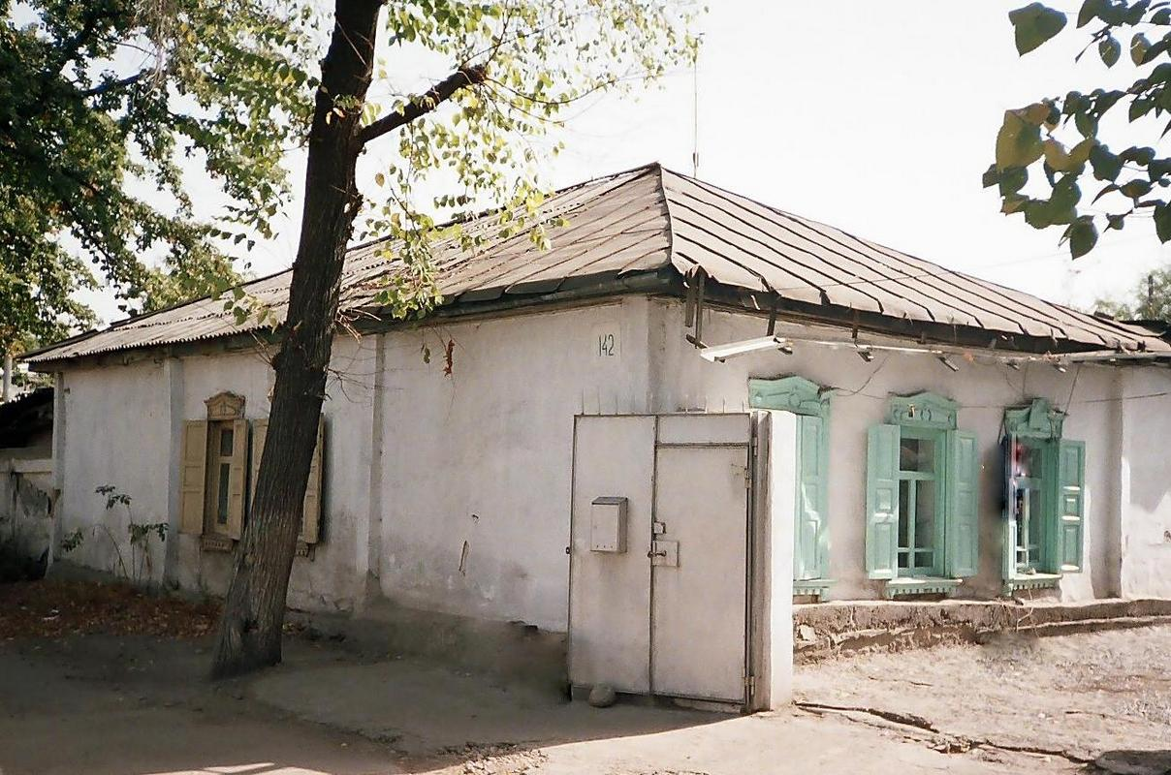
Дом на пересечении улиц Константиновской и Грязновской.
ENGLISH House at the intersection of Konstantinovskaya and Gryaznovskaya streets.
﻿ House at the intersection of Konstantinovskaya and Gryaznovskaya The construction of residential buildings in the city of Pishpek was carried out strictly according to plan. Rectilinear streets formed squares or rectangles of blocks and in one block there were four to six plots, each with an area of ​​0.1 hectares. Houses on courtyard estates were placed on the corner or in the center of the site, with the main facades facing the street. The ro
Source: https://bimap.su/description/pishpek/126_Dom_na_Konstantinovskoi.txt · BIMAP
Фотографии и материалы принадлежат их авторам; лицензия не указана

FRUNZE
No information has been found for this period yet
42.87230, 74.59338

Фотография пока не добавлена
ENGLISH
No information has been found for this period yet.

BISHKEK
No information has been found for this period yet
42.87230, 74.59338

Фотография пока не добавлена
ENGLISH
No information has been found for this period yet.

