PISHPEK
House of the merchant Morozov
42.88269, 74.60472
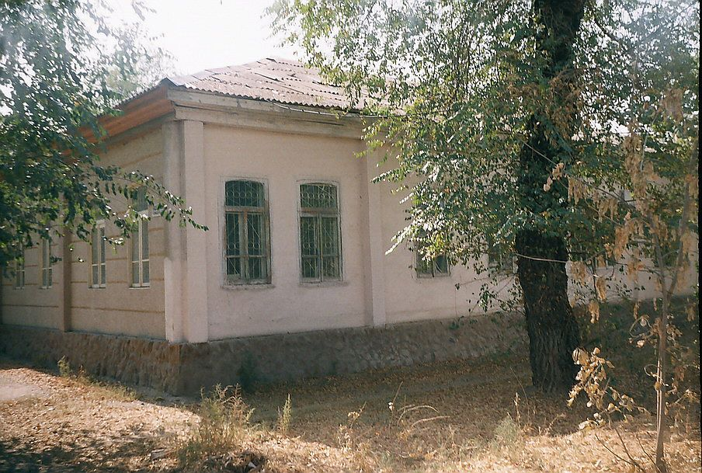
Дом купца Морозова
ENGLISH House of the merchant Morozov
﻿ House of the merchant Morozov. At the beginning of the twentieth century, Morozov was famous for his philanthropy in the field of education. In several of his houses he maintained school rooms. This house was a school for girls, during Soviet times, primary school No. 27.
Source: https://bimap.su/description/pishpek/124_Dom_Morozova.txt · BIMAP
Фотографии и материалы принадлежат их авторам; лицензия не указана

FRUNZE
No information has been found for this period yet
42.88269, 74.60472

Фотография пока не добавлена
ENGLISH
No information has been found for this period yet.

BISHKEK
No information has been found for this period yet
42.88269, 74.60472

Фотография пока не добавлена
ENGLISH
No information has been found for this period yet.

