PISHPEK
House of the merchant Morozov
42.88273, 74.60531
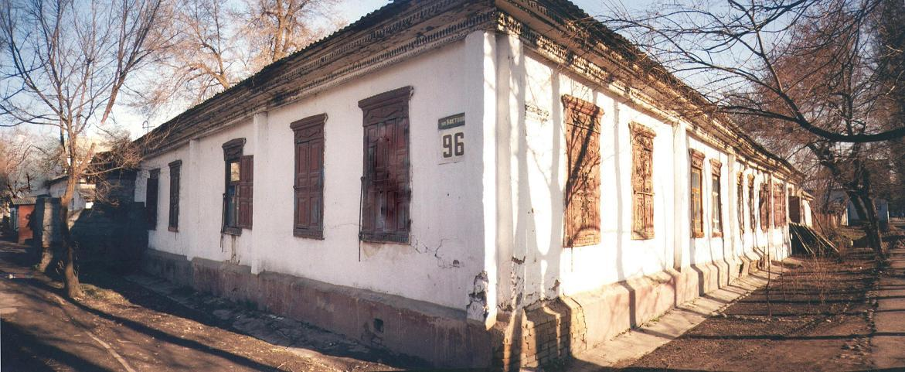
Дом купца Морозова · Никиты Часова
ENGLISH House of the merchant Morozov
﻿ House of the merchant Morozov on Vasilyevskaya and Alamedinskaya. At the beginning of the twentieth century, Morozov was famous for his philanthropy in the field of education. He maintained school rooms in several of his houses. In 1909, a Russian-native boarding school was opened in this house at the city school, in which up to 25 Kyrgyz and Russian boys lived.
Source: https://bimap.su/description/pishpek/123_Dom_Morozova.txt · BIMAP
Фотографии и материалы принадлежат их авторам; лицензия не указана

FRUNZE
No information has been found for this period yet
42.88273, 74.60531

Фотография пока не добавлена
ENGLISH
No information has been found for this period yet.

BISHKEK
No information has been found for this period yet
42.88273, 74.60531

Фотография пока не добавлена
ENGLISH
No information has been found for this period yet.

