PISHPEK
Kubyshkin's House
42.88087, 74.58156
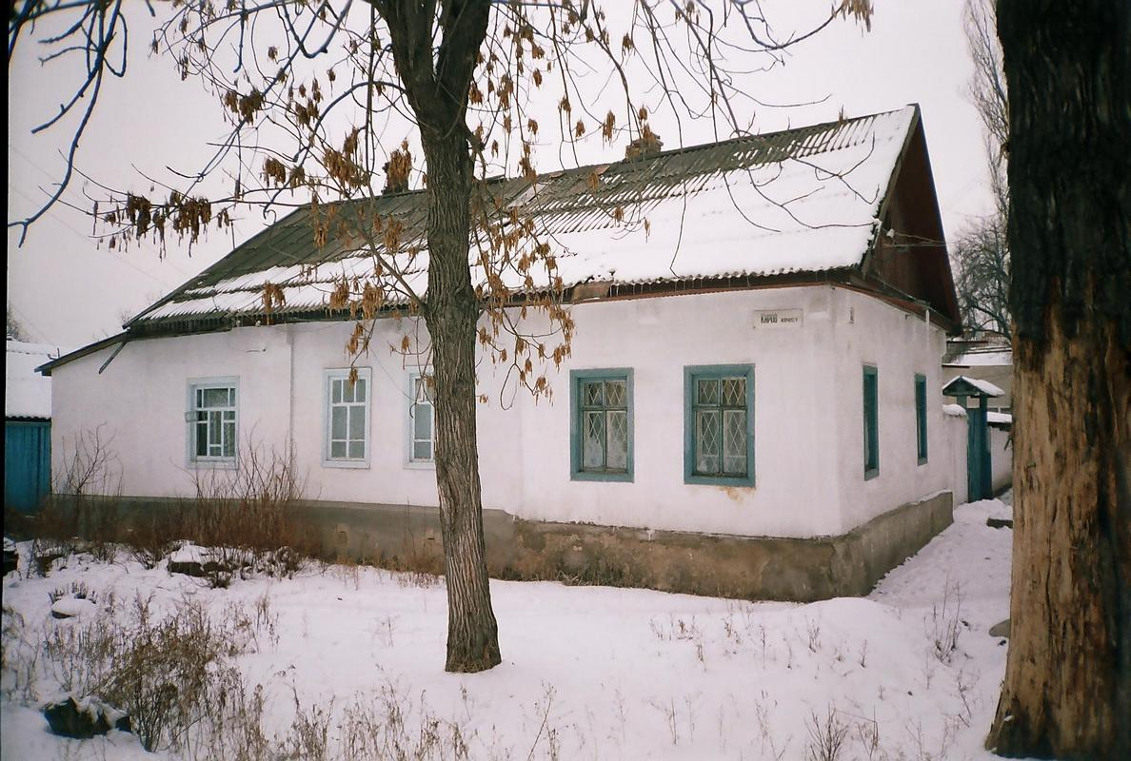
Дом Кубышкина · Никиты Часова
ENGLISH Kubyshkin's House
﻿ Kubyshkin's House at the intersection of Uezdnaya and Nikolaevskaya In 1882, a large group of Dungan refugees from China arrived in Pishpek. They were accepted into Russian citizenship and settled compactly on the western outskirts of the city of Pishkek, forming the so-called Dungan settlement. Dungan estates were located here freely, as was always done in Dungan settlements, and all undeveloped space was occupied by fields and vegetable garde
Source: https://bimap.su/description/pishpek/121_Dom_Kubyshkina.txt · BIMAP
Фотографии и материалы принадлежат их авторам; лицензия не указана

FRUNZE
No information has been found for this period yet
42.88087, 74.58156

Фотография пока не добавлена
ENGLISH
No information has been found for this period yet.

BISHKEK
No information has been found for this period yet
42.88087, 74.58156

Фотография пока не добавлена
ENGLISH
No information has been found for this period yet.

