PISHPEK
House on Boulevard Street
42.86713, 74.60525
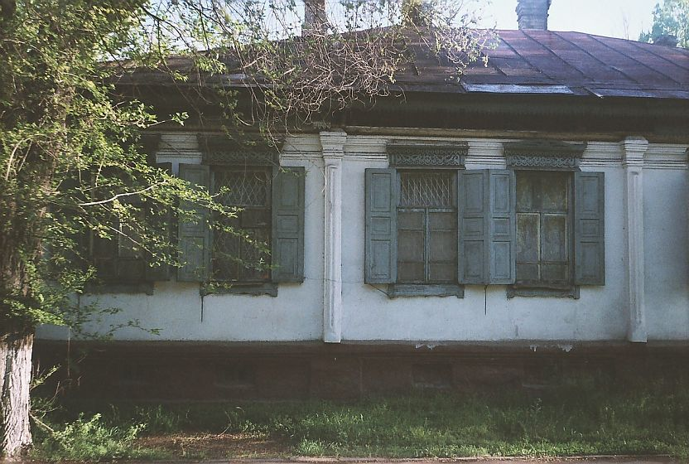
Дом на улице Бульварной · Владимира Петрова
ENGLISH House on Boulevard Street
﻿ House on the corner of Boulevard and Verkhnyaya. Beginning of the twentieth century. The end of the 19th and beginning of the 20th centuries was characterized by the improvement of the city and the construction of large houses at the head of the city estate. The houses stood on high stone foundations made of cobblestones or ashlars, above which there was a brick basement of the semi-basement or first floor with patterned decor of the brickwork.
Source: https://bimap.su/description/pishpek/117_Dom_na_Bulvarnoi.txt · BIMAP
Фотографии и материалы принадлежат их авторам; лицензия не указана

FRUNZE
No information has been found for this period yet
42.86713, 74.60525

Фотография пока не добавлена
ENGLISH
No information has been found for this period yet.

BISHKEK
No information has been found for this period yet
42.86713, 74.60525

Фотография пока не добавлена
ENGLISH
No information has been found for this period yet.

