PISHPEK
District forestry
42.88076, 74.60638
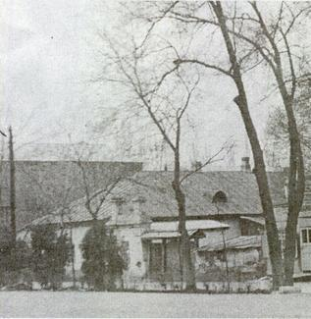
Уездное лесничество
ENGLISH District forestry
﻿ District forestry on Boulevard Landscaping was considered an important element in the improvement of cities and towns in Semirechye. And the city of Pishpek was successfully greened, groves rose around it. Here, along with local trees, oak, hornbeam, and birch trees brought from afar successfully took root. The regional governor, Gerasim Alekseevich Kolpakovsky, was a passionate advocate of landscaping. There was even a legend that Kolpakovsky
Source: https://bimap.su/description/pishpek/116_Lesnichestvo.txt · BIMAP
Фотографии и материалы принадлежат их авторам; лицензия не указана

FRUNZE
No information has been found for this period yet
42.88076, 74.60638

Фотография пока не добавлена
ENGLISH
No information has been found for this period yet.

BISHKEK
No information has been found for this period yet
42.88076, 74.60638

Фотография пока не добавлена
ENGLISH
No information has been found for this period yet.

