PISHPEK
South side of Tserkovnaya street
42.87918, 74.58243
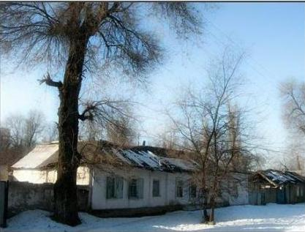
Южная сторона улицы Церковной · Виктора Глумскова
ENGLISH South side of Tserkovnaya street
﻿ South side of Tserkovnaya street. On the right is the intersection with Nikolaevskaya Street. In 1882, a large group of Dungan refugees from China arrived in Pishpek. They were accepted into Russian citizenship and settled compactly on the western outskirts of the city of Pishkek, forming the so-called Dungan settlement. Dungan estates were located here freely, as was always done in Dungan settlements, and all undeveloped space was occupied by
Source: https://bimap.su/description/pishpek/115_Ug_Tserkovnoi.txt · BIMAP
Фотографии и материалы принадлежат их авторам; лицензия не указана

FRUNZE
No information has been found for this period yet
42.87918, 74.58243

Фотография пока не добавлена
ENGLISH
No information has been found for this period yet.

BISHKEK
No information has been found for this period yet
42.87918, 74.58243

Фотография пока не добавлена
ENGLISH
No information has been found for this period yet.

