PISHPEK
House of the Muladzhanovs
42.87680, 74.60872
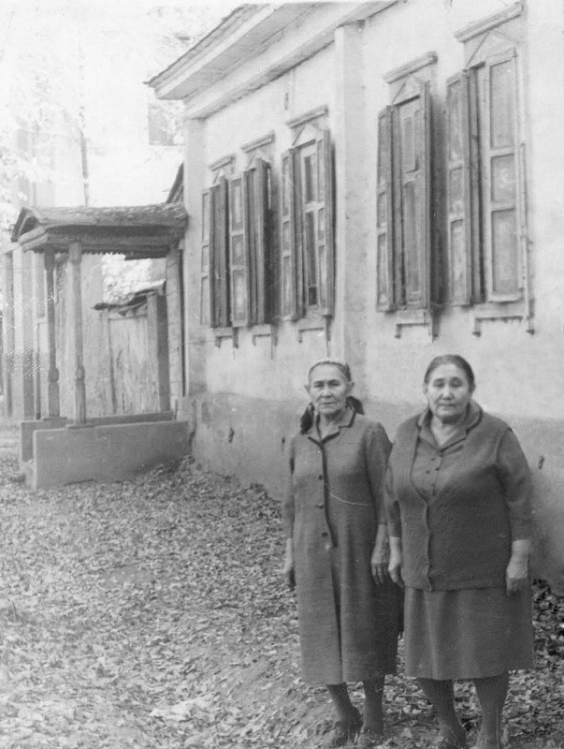
Дом Муладжановых
ENGLISH House of the Muladzhanovs
﻿ House of the Muladzhanovs in 1896 on Tatarskaya The construction of residential buildings in the city of Pishpek was carried out strictly according to plan. Rectilinear streets formed squares or rectangles of blocks and in one block there were four to six plots, each with an area of ​​0.1 hectares. Houses on courtyard estates were placed on the corner or in the center of the site, with the main facades facing the street. The roofs of rich build
Source: https://bimap.su/description/pishpek/114_Dom1896.txt · BIMAP
Фотографии и материалы принадлежат их авторам; лицензия не указана

FRUNZE
No information has been found for this period yet
42.87680, 74.60872

Фотография пока не добавлена
ENGLISH
No information has been found for this period yet.

BISHKEK
No information has been found for this period yet
42.87680, 74.60872

Фотография пока не добавлена
ENGLISH
No information has been found for this period yet.

