PISHPEK
Uzbek school
42.87541, 74.61195
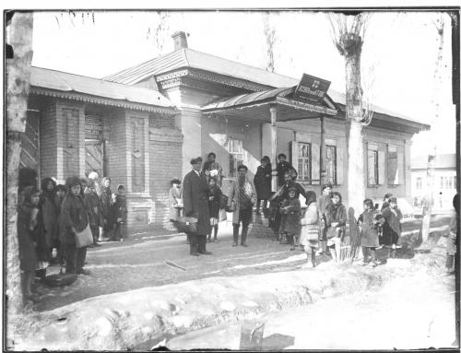
Узбекская школа
ENGLISH Uzbek school
﻿ Uzbek school. Bazarnaya x Kupecheskaya, south-eastern corner, 1925. In 1921, the Pishpek department of public education sent a group of teachers to courses in the city of Verny. Among them was Salizhan Tursunov, who became the first director of the Uzbek school, located in one of the rooms of the teacher’s house. In 24-25 the house was completely transferred to the school. School No. 24 was created on the basis of this school.
Source: https://bimap.su/description/pishpek/111_Uzbekskaia_shkola1925.txt · BIMAP
Фотографии и материалы принадлежат их авторам; лицензия не указана

FRUNZE
No information has been found for this period yet
42.87541, 74.61195

Фотография пока не добавлена
ENGLISH
No information has been found for this period yet.

BISHKEK
No information has been found for this period yet
42.87541, 74.61195

Фотография пока не добавлена
ENGLISH
No information has been found for this period yet.

