PISHPEK
Kuznechnaya Street
42.88035, 74.61644
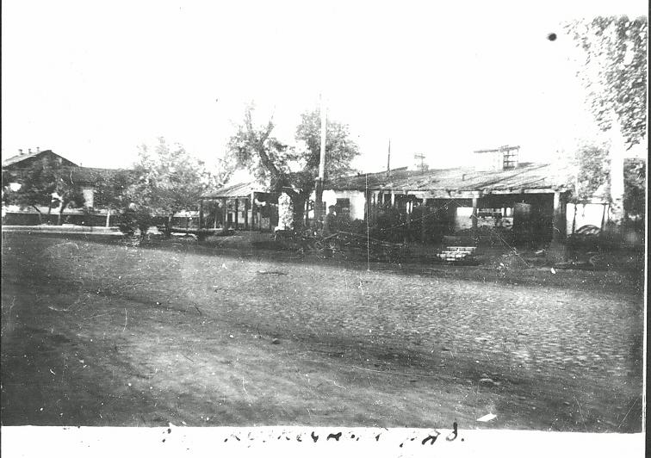
Улица Кузнечная
ENGLISH Kuznechnaya Street
﻿ Tokmakskaya x Kolpakovskaya Along the banks of the Kuznechnaya River there are numerous workshops of tinsmiths and blacksmiths. Horses were shoed here and carts were repaired. Forges at that time performed work comparable to today's car service stations. There were a lot of carts and horse-drawn vehicles and there was enough work for everyone.
Source: https://bimap.su/description/pishpek/108_Vostok_Kuznechnoi.txt · BIMAP
Фотографии и материалы принадлежат их авторам; лицензия не указана

FRUNZE
No information has been found for this period yet
42.88035, 74.61644

Фотография пока не добавлена
ENGLISH
No information has been found for this period yet.

BISHKEK
No information has been found for this period yet
42.88035, 74.61644

Фотография пока не добавлена
ENGLISH
No information has been found for this period yet.

