PISHPEK
House of the Khalilovs
42.88247, 74.60155
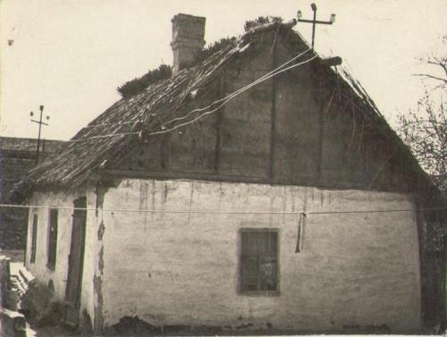
Дом Халиловых · Владимира Петрова
ENGLISH House of the Khalilovs
﻿ House of the Khalilovs on Sadovaya Street Even in the central part of the city, some houses bore the appearance of rural buildings and looked like temporary huts. They were built from adobe or on wooden frames filled with clay (gaulak) with reed roofs. Often such buildings were unauthorized and were erected during times of wars and revolutions.
Source: https://bimap.su/description/pishpek/102_Dom_Halilovyh.txt · BIMAP
Фотографии и материалы принадлежат их авторам; лицензия не указана

FRUNZE
No information has been found for this period yet
42.88247, 74.60155

Фотография пока не добавлена
ENGLISH
No information has been found for this period yet.

BISHKEK
No information has been found for this period yet
42.88247, 74.60155

Фотография пока не добавлена
ENGLISH
No information has been found for this period yet.

